**Differentially expressed genes analysis of the selective genes between adrenal and thyroid in human tissues**

**Abstract**

Adrenal and thyroid in human body are two functionally related tissues, which both control the hormone secretion and regulate the metabolism. In a database called the PaGenBase, which collects the 11 model organism pattern genes expression information, I get the selective genes of the two tissues. In this research, I would like to do the differential expression analysis with the transcriptome data of human. The methods include the quality control of the raw data, aligning reads to the reference genome, the genome-guided transcriptome assembly, calculating the expression level, overall quality evaluation of thee RNA sequencing, the enrichment analysis and protein-protein interaction network analysis. In the differential expression result we can see, there are two genes in the selective genes are downregulated in the adrenal compared to thyroid (BMP7, CLIC3) and three genes upregulated in the adrenal compared to thyroid(INHA, DLK1, CYP11A1). Based on enrichment analysis, we can see the pathways of genes upregulated in the thyroid and downregulated in the adrenal are mainly for the thyroid hormone regulation and cell-cell junction, while for the genes upregulated in the adrenal and downregulated in the thyroid, the pathways are mainly for steroid regulation, neuron interaction and passive transport. From the PPI analysis, I look up the five differentially expressed pattern genes, and find the gene CYP11A1 is significantly interacted with multiple genes, which indicates an essential function for adrenal.

**Introduction**

Tissue specifically expressed genes are genes which are specifically or selectively expressed in one or several tissues. They tend to have strong association with the specific functions in tissues. In human tissues, there are four gene expression patterns: housekeeping genes, which are uniformly expressed in all tissues and tend to lead to diseases if mutated, specific genes, which are specifically expressed in one tissue but not others and they can indicate the specific functions of corresponding tissues, the selective genes, which are selectively expressed in several tissues and indicate the connectivity among the tissues, repressed genes, which are expressed in a very low level in tissues. We can also use the selective genes as biomarkers for the specific tissues. In a database called PaGenBase, gene expression profiles in specific tissue and condition of 11 model organisms can be found. The data comes from integration of microarray, NGS dataset and literature.

Since the adrenal and thyroid are two functionally related tissues, which both regulate the metabolism and can be classified into gland in human tissue classification, I want to analyze how differentially their selective genes are expressed. In PaGenBase, the selective genes in adrenal and thyroid are: AGTR1, CYP11A1, DLK1, INHA , POR and BMP7, CLIC3, POR, TRIM58, respectively.

Then i need to do the differential expression analysis between these two tissues. The transcriptome datasets for adrenal and thyroid tissues have 3 and 4 replicates, respectively. The datasets are then processed from quality control to enrichment analysis. The workflow is showed in the figure1.

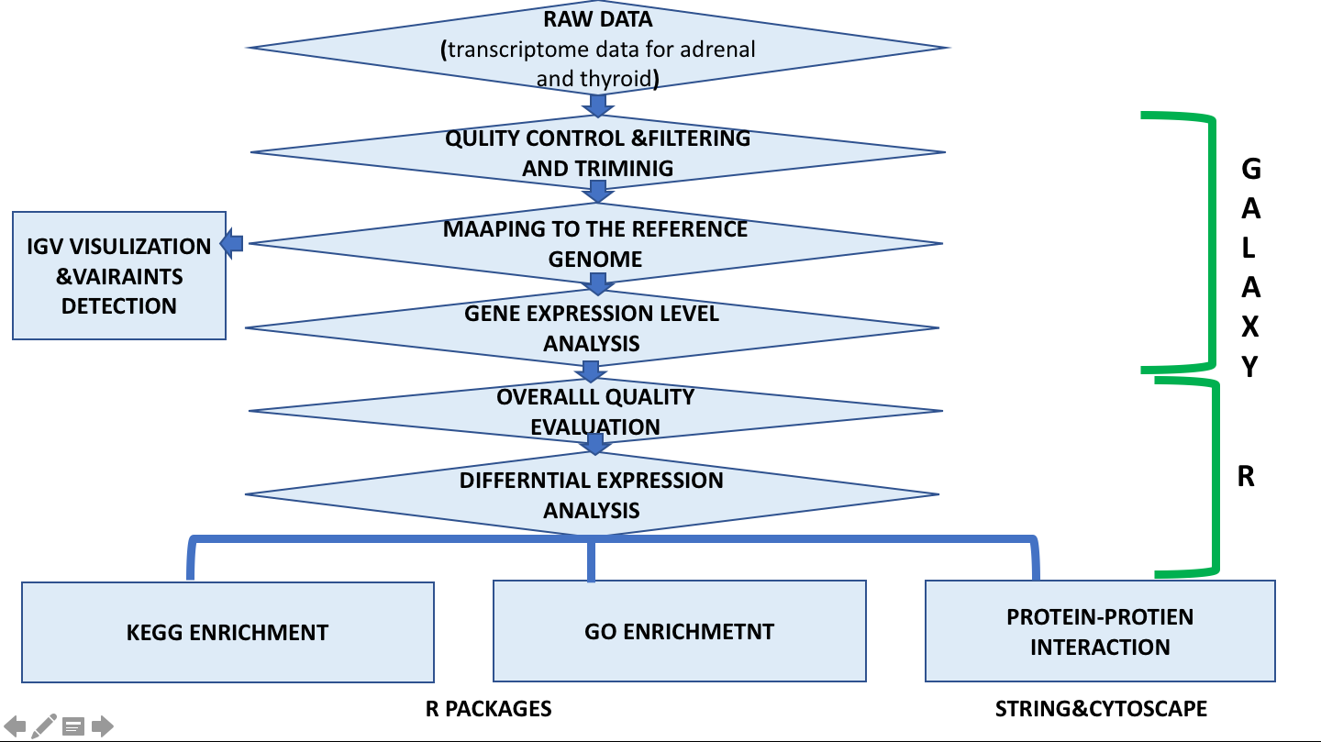

**Figure 1 the workflow of the whole RNA-seq analysis**

For the quality control, mapping to reference genome, gene expression level analysis, I do them in the Galaxy, a web server with multiple useful software. After I get the annotated and integer counted genes, the following steps are completed in R. Since I annotate the genes with gene name, I first do the ID mapping to convert gene names to ENTREZ ID, which will be used in the enrichment analysis. Then I do the overall quality evaluation for the transcriptome data and then differential expression analysis, and I choose the first 1000 significantly differentially expressed genes with the cutoff p-value 0.05. The table of these genes can be opened in the excel and I split them into upregulated and downregulated based on the LogFC. (Since the pair input is thyroid vs. adrenal, the upregulated means the genes are highly expressed in the adrenal compared to thyroid and their Log FC is positive , and vice versa.) I check the selective genes in the table and find that the gene BMP7 and CLIC3 appear in the downregulated table, while gene INHA, DLK1 and CYP11A1 appear in the upregulated table. This agree with the PaGenBase result but we can also see some of the selective genes are not so significantly differentially expressed between the two tissues.

Then I do the enrichment analysis for the upregulated and downregulated genes, respectively. The results will be discussed in the Result section.

To analyze the protein-protein interaction, I first convert the ENTREZ IDs into the protein IDs with Uniprot ID mapping for the upregulated and downregulated, respectively. Then I generate the protein-interaction tables in the STRING, put them in the Cytoscape and analyze the differentially expressed selective genes. An interesting point is that in the downregulated genes, the CYP11A1 is connected with many other genes with significant scores, and the BMP7 in the upregulated genes is also connected multiple genes with significant scores. This indicate the potential key function in them.

**Methods**

Quality control of reads

Raw reads are scanned for low-quality bases, biased nucleotide composition, adapters, duplicates, sequence contamination, etc. The tool is FastQC on Galaxy platform. The output file is a statistics summary text for the preprocessing in the next step.

Preprocessing of reads

The tool is Trim Galore also on Galaxy platform. The filtering and trimming of the reads can produce the clean reads, after removing the poly-A tails, the low-quality reads, and the reads with wrong length. The reads are sing-ended.

Aligning reads to a reference genome

The Tophat2 on galaxy can align the reads to reference hg19 genome. All the reads are sing-ended.

Genome-guided transcriptome assembly

Cufflinks on galaxy can assemble reads with the reference genome.

Calculating expression levels

FeatureCounts on galaxy can produce the integer reads counts per gene, and then can be used by edgeR and Deseq2 to do differential expression analysis. The annotation file is gencode.v17.annotation.gtf, which annotate with gene names rather than ID.

Differential expression analysis

After I get the annotated file, I put it into R. Before I do the differential expression analysis, I first do the ID mapping with the org.Hs.eg.db as database to convert the gene names to ENTREZID. In this step, I first map each gene name to one ENTREZ ID with the most counts. I remove the duplicated ones and the not matched gene names. The rows before and after mapping is round 50000 to around 20000. Then I use the edgeR package to do the normalization and statistical test for sample groups relationship. With the cutoff p-value 0.05 I get the differentially expressed genes. The pairs are thyroid vs adrenal, which means the result logFC is to compare the adrenal expression level with the thyroid. To select the most significant differentially expressed gene, I sort the genes by their p-value and choose the first 1000. I write them into the table. Then I open it in the Excel and split them into the upregulated ones and downregulated ones. (supplement table1 and table2)

Visualization of data in genomic context

IGV can be used for visualize the reads deletion, insertion and exon junctions in the context of genome.(figure2) As you can see from the figure, we can find the variants.

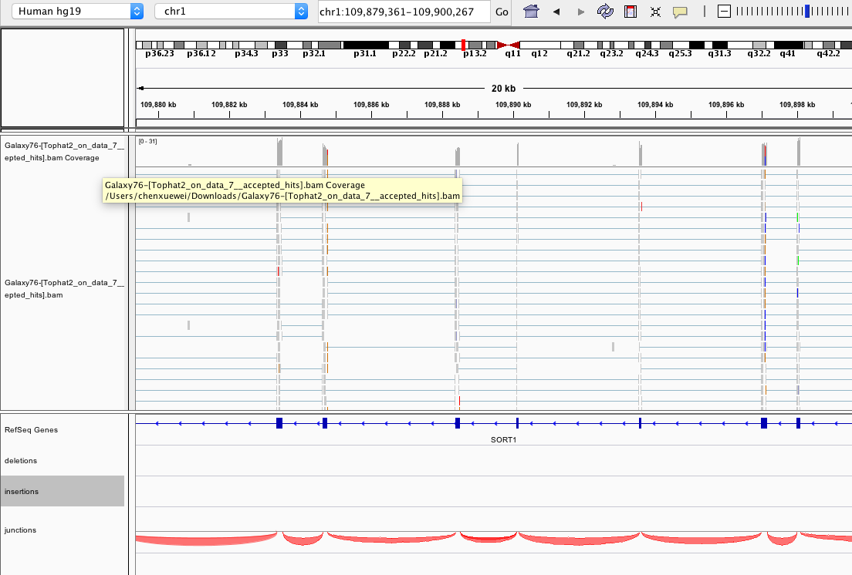

**Figure 2 screenshot of IGV**

As you can see from the picture, they are accepted_hits, insertion, deletion and junctions files of one adrenal replicate in the context of the genome hg19. The chromosome is chromosome 1. We can find the variants by this.

Gene set enrichment analysis

GO and KEGG pathway enrichment analysis can be done by R package clusterprofile. With the R package clusterprofile, I input the converted ENTREZ IDs for the upregulated and downregulated genes respectively, set the cutoff p-value 0.01 and get the GO and KEGG enrichment analysis table.(figure3) As you can see, the pathways are ranked base on the p-value. Then I can get the dotplots of the first ten pathways for each table. (figure 4)

**Figure 3 the screenshot of the KEGG pathway (a) and GO pathway (b) enrichment result for down regulated genes**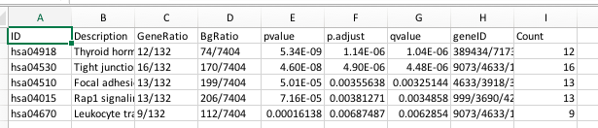

1. the KEGG pathway enrichment for downregulated genes

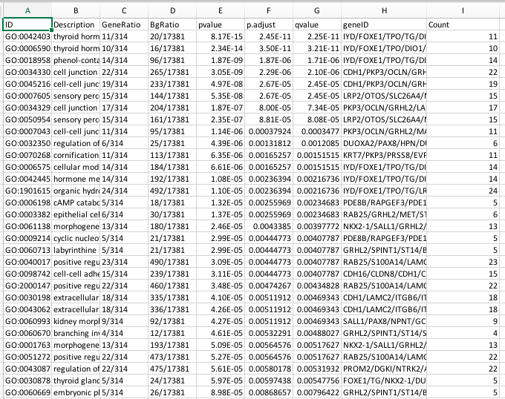

b. the GO pathway enrichment for downregulated genes (ontology biological process)

**Figure 4 the dotplots of the GO pathway (a) and KEGG pathway (b) enrichment result for down regulated genes**

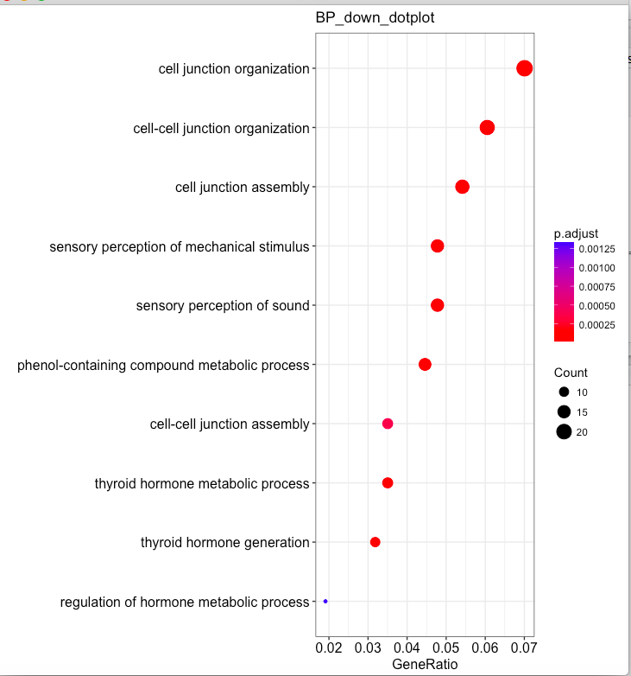

a

the dotplot for first 10 GO enriched pathways of biological process for downregulated genes

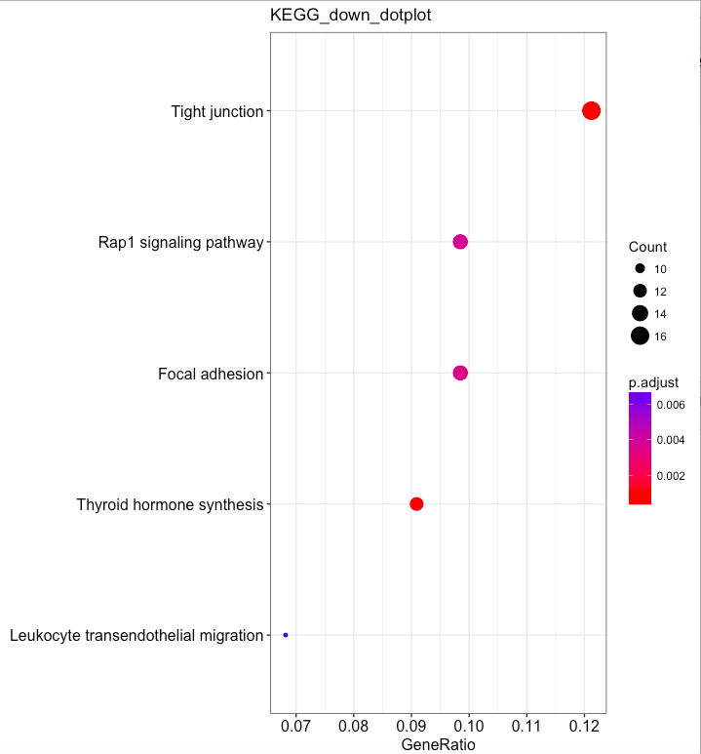

b

the dotplot for first ten enriched KEGG pathways for downregulated genes

Protein-protein interaction network analysis

I put the upregulated and downregulated genes into Uniprot to get their corresponding protein IDs and then analyze their interaction with STRING. I use the Cytoscape to analyze the result. I check for the five differentially expressed selective genes in the node table in Cytoscape. (figure5)

**Figure5 the screenshot of interaction evidence for gene BMP7**

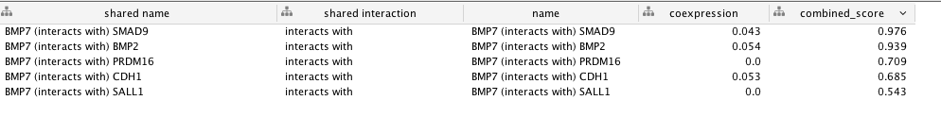

**Result**

For the quality control part, the overall quality is quite good. The GC content is around 50% for the 7 files and there is no poor quality reads. For the trimming and filtering, there is no too short or long reads in all 7 files, the trimmed percentage is around 38% for the thyroid data and 47% for adrenal. The quality trimmed percentage for thyroid is around 1% and for adrenal is 2%. For the read mapping ,there is around 90% percentage mapped reads for the thyroid data and 65%~75% mapped reads for adrenal data.

For the sample relationship part, we can see MDS plot, the smear plot, the PCA plot, the sample distance heatmap, the differential expressed genes heatmap.(figure 6) The plots show good quality for the overall data, since there is a clear difference between the two tissues and little variance within replicates of one tissue.

For the differential expression analysis, from the GO and KEGG enrichment analysis we can see the mainly differentially expressed pathways between the two tissues. (figure 7)In the adrenal, the pathways associated with passive transport, the ion channel transport neurotransmitter secretion, transportation and regulation are highly expressed, while in the thyroid, the cell-cell adhesion and junction and thyroid hormone regulation are highly expressed.

For the PPI analysis, I check for those differentially expressed selective genes. For the upregulated ones INHA,DLK1 and CYP11A, the gene CYP11A shows high correlation with other upregulated genes. For the downregulated ones CLIC3 and BMP7, the BMP7 shows relatively high correlation with other ones. This result indicates theses two genes may have potential key functions for the two tissues.(figure 8)

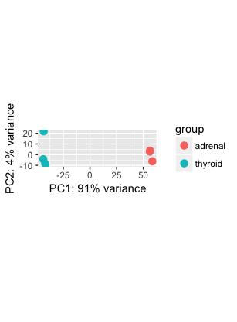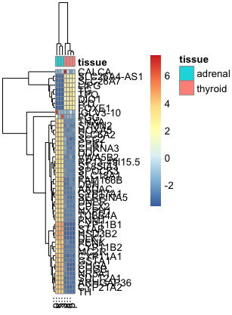

a

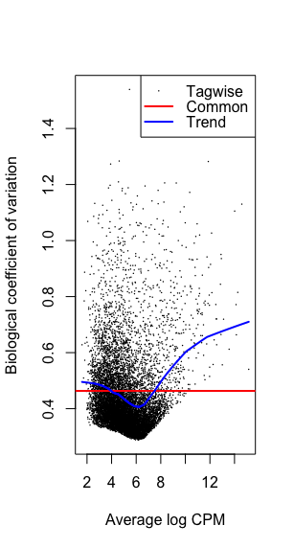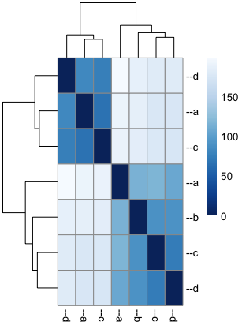

b

d

c

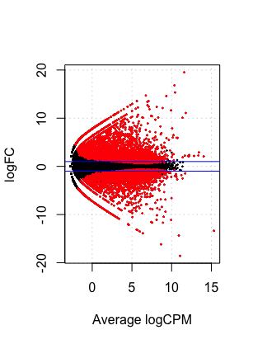

**Figure 6 the differential expression plots**

1. The PCA plot for these 7 samples. It is clear that the PCA1 can mostly divide the two tissues apart.
2. The differential expressed gene heatmap. From the heatmap we can see, the genes can roughly be divided into two categories. One category of genes is highly expressed in one tissue but repressed in the other, and vice versa.
3. BCV plot. In this case the common BCV is roughly 0.4, which is normal in human.
4. Sample relationship heatmap. As you can see, the samples are significantly divided into two groups, the first three and the last four.
5. Smear plot

e

**Figure 7 the dotplots for GO and KEGG enrichment**

As you can see, each plot has its title to annotate itself.

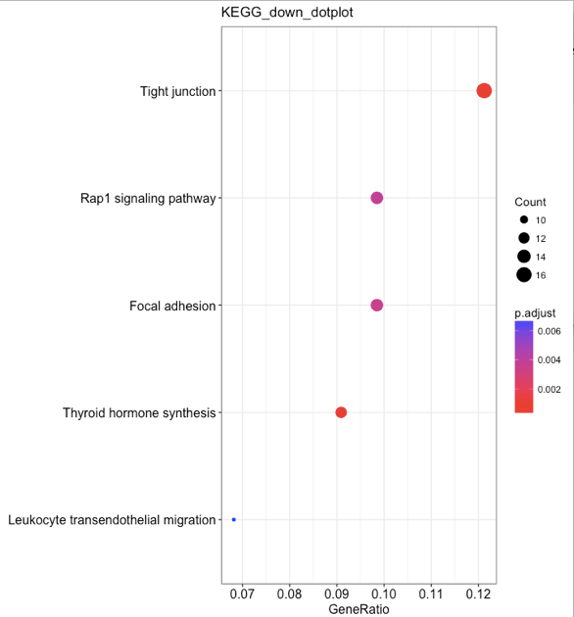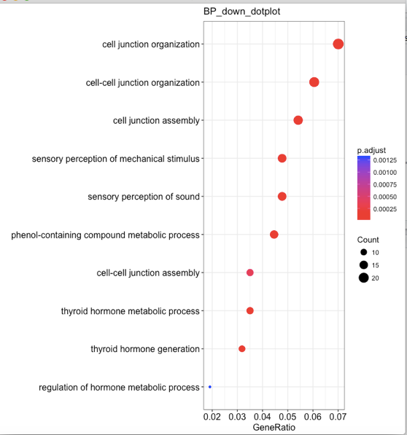

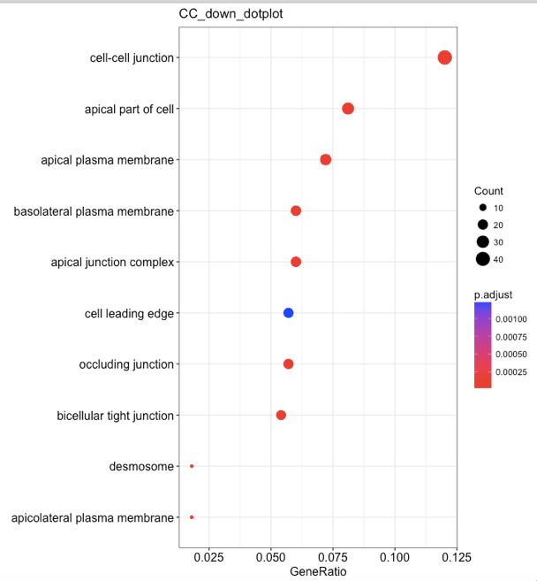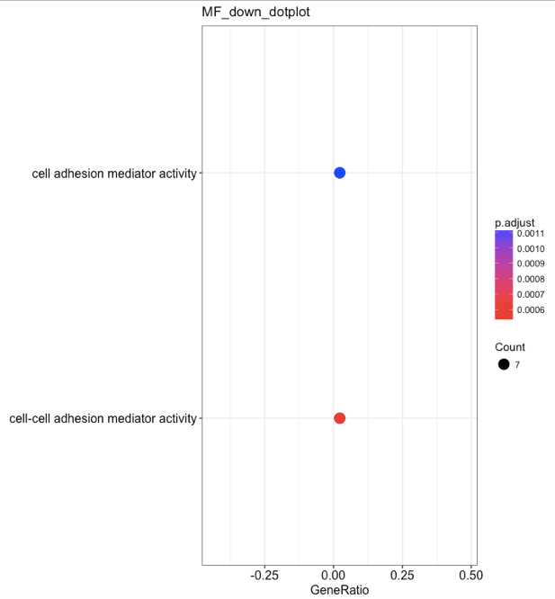

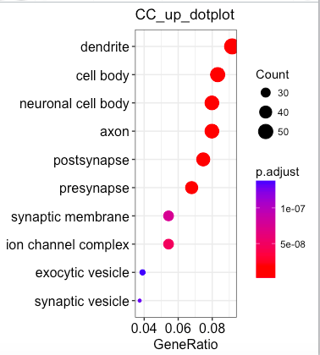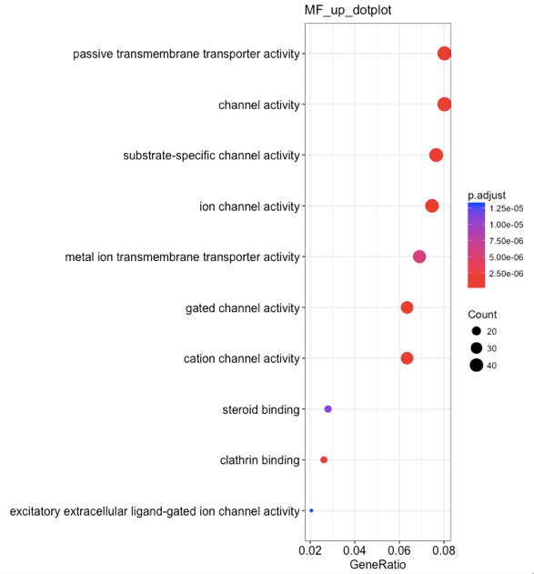

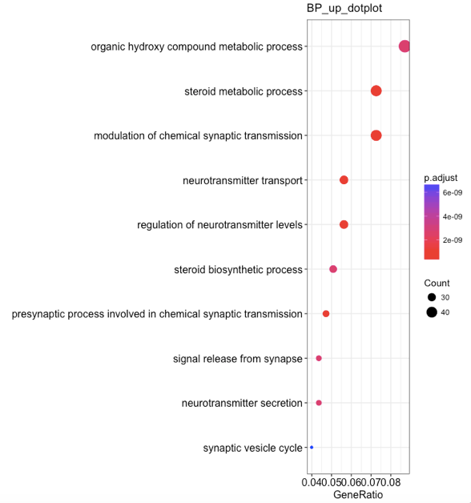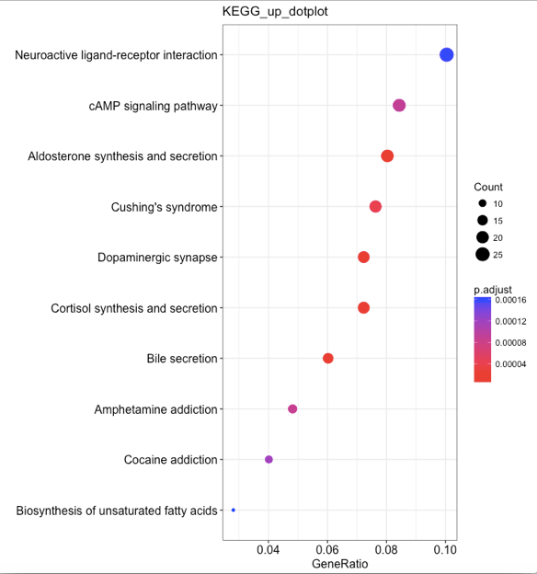

**Figure 8 the screenshot of the five selective genes interaction evidence**

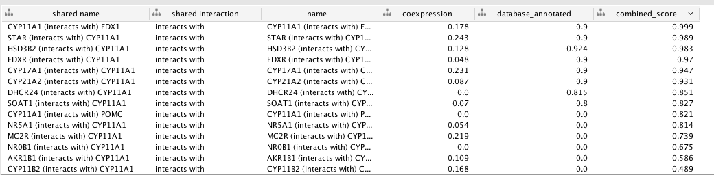





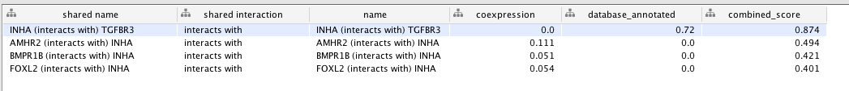



**Discussion**

There is an interesting point in my research, in the 1000 differentially expressed genes, more than 600 of them are upregulated and 300 of them are downregulated. Also in the enrichment analysis, the pathways for the upregulated ones are far more diverse and have a much larger quantity. This may indicate the more diverse function in the adrenal than thyroid. Also for the gene BMP7 and CYP11A, which are selective genes for thyroid and adrenal respectively, with the high correlation with other genes, they tend to have the key function for the two tissues.

**Reference**

Qin, Y. *et al.* Pattern Genes Suggest Functional Connectivity of Organs. *Sci. Rep.* **6**, 26501; doi: 10.1038/srep26501 (2016)

Pan JB, Hu SC, Shi D, Cai MC, Li YB, Zou Q, Ji ZL*. PaGenBase: a pattern gene database for the global and dynamic understanding of gene function. PLoS ONE.  2013 Dec 2;8(12):e80747.

RNA-seq Data Analysis-A Practical Approach(2016)

<https://wenku.baidu.com/view/f25003c203d8ce2f0166239c.html?rec_flag=default&sxts=1523931955070>

<https://pilot1.globusgenomics.org>

<https://string-db.org/>

<http://www.uniprot.org/>

**Supplement data**

**Table 1 thyroid vs. adrenal downregulated genes table**

ENTREZID gene_name SYMBOL logFC logCPM PValue FDR

11166 2304 FOXE1 FOXE1 -16.20011976 8.854922668 1.48E-140 4.36E-137

16488 389434 IYD IYD -18.60076125 11.25496339 1.81E-130 4.43E-127

16029 3773 KCNJ16 KCNJ16 -10.20686026 8.34756985 2.04E-113 3.99E-110

12042 256764 WDR72 WDR72 -11.60188503 7.636689531 1.26E-108 2.18E-105

29362 999 CDH1 CDH1 -9.013286711 8.708829919 3.30E-90 4.61E-87

2781 10053 AP1M2 AP1M2 -13.26992915 5.92960204 1.32E-88 1.76E-85

17306 4036 LRP2 LRP2 -11.73026727 7.768466687 1.36E-78 1.43E-75

16148 3855 KRT7 KRT7 -8.708941135 8.39562775 2.38E-76 2.26E-73

25783 79413 ZBED2 ZBED2 -13.92338377 6.581008385 1.18E-73 9.92E-71

16851 3918 LAMC2 LAMC2 -7.506267346 6.018093921 2.48E-72 2.03E-69

14423 29842 TFCP2L1 TFCP2L1 -6.4209824 7.466916654 5.14E-70 3.97E-67

24502 7038 TG TG -13.44108273 15.54891129 1.31E-69 9.59E-67

9452 153562 MARVELD2 MARVELD2 -7.260429258 6.182778269 9.10E-68 6.21E-65

18755 50506 DUOX2 DUOX2 -7.041166849 8.395158839 8.52E-66 5.32E-63

16028 3772 KCNJ15 KCNJ15 -8.846091284 7.498431862 1.30E-65 7.94E-63

27122 84239 ATP13A4 ATP13A4 -6.908685729 6.289216624 7.70E-64 4.35E-61

24135 6819 SULT1C2 SULT1C2 -8.714890103 5.445847854 1.31E-62 6.98E-60

7514 114569 MAL2 MAL2 -6.176296469 7.79111423 5.75E-62 2.96E-59

12875 27124 INPP5J INPP5J -7.620657603 8.154486479 5.64E-60 2.72E-57

10034 1733 DIO1 DIO1 -11.14369364 8.313939612 3.77E-59 1.76E-56

26152 80004 ESRP2 ESRP2 -6.689956573 5.290021069 1.90E-58 8.45E-56

11377 23286 WWC1 WWC1 -6.368392368 6.408292893 1.10E-56 4.67E-54

10121 1829 DSG2 DSG2 -4.908771735 7.267319863 1.33E-55 5.42E-53

25537 7804 LRP8 LRP8 -5.45103441 6.79119028 7.23E-55 2.87E-52

24632 7173 TPO TPO -14.4066806 11.11638601 1.13E-54 4.38E-52

22046 596 BCL2 BCL2 -3.878821885 7.762350576 1.87E-54 7.14E-52

24543 7080 NKX2-1 NKX2-1 -8.425282068 5.79050637 2.19E-54 8.24E-52

2632 100506658 OCLN OCLN -7.653484316 5.699702378 1.77E-52 6.28E-50

15137 3400 ID4 ID4 -6.91585578 8.829168307 9.09E-50 2.87E-47

26137 79977 GRHL2 GRHL2 -7.578314581 4.961009236 4.97E-49 1.52E-46

21302 57111 RAB25 RAB25 -9.432275032 4.968563629 7.65E-49 2.32E-46

25988 79784 MYH14 MYH14 -5.779756305 6.232592925 2.16E-48 6.40E-46

16303 387914 SHISA2 SHISA2 -8.682172778 5.656003137 6.17E-48 1.81E-45

17556 4093 SMAD9 SMAD9 -4.117378902 7.360076286 1.81E-47 5.22E-45

26102 79924 ADM2 ADM2 -8.018624575 5.199238264 1.89E-46 5.24E-44

14609 3081 HGD HGD -8.721922962 5.452246804 2.79E-46 7.65E-44

14616 30818 KCNIP3 KCNIP3 -4.522089751 5.19042193 2.21E-45 5.64E-43

9147 147798 TMC4 TMC4 -6.248564246 5.681181306 8.97E-45 2.25E-42

21675 57604 KIAA1456 KIAA1456 -6.323986723 7.174955543 4.73E-44 1.16E-41

19379 5172 SLC26A4 SLC26A4 -9.47134802 9.432512309 5.72E-44 1.39E-41

9700 161291 TMEM30B TMEM30B -4.737923281 6.970838538 1.51E-43 3.64E-41

18565 4915 NTRK2 NTRK2 -5.411242848 9.252668126 3.08E-43 7.35E-41

15221 341640 FREM2 FREM2 -4.853844765 5.738375156 7.71E-43 1.83E-40

27296 84561 SLC12A8 SLC12A8 -6.22123046 5.519515295 7.09E-42 1.63E-39

9645 159195 USP54 USP54 -3.547914579 7.329340577 1.29E-41 2.93E-39

9584 158158 RASEF RASEF -5.665359453 6.488388227 2.38E-41 5.38E-39

25709 79170 PRR15L PRR15L -9.256797405 5.684954793 3.64E-41 8.05E-39

22410 6299 SALL1 SALL1 -8.342837743 6.03821582 3.59E-40 7.52E-38

20133 54947 LPCAT2 LPCAT2 -3.315860158 8.26278859 6.50E-40 1.33E-37

5072 10411 RAPGEF3 RAPGEF3 -3.60384713 6.822027795 3.29E-39 6.44E-37

21571 57475 PLEKHH1 PLEKHH1 -3.179201053 8.019859442 3.81E-39 7.40E-37

10248 196475 RMST RMST -5.096593587 5.329272905 1.59E-38 2.96E-36

18850 50937 CDON CDON -4.289520494 6.630334666 3.64E-38 6.65E-36

21061 56477 CCL28 CCL28 -4.323171897 5.559284738 5.32E-38 9.64E-36

20032 54845 ESRP1 ESRP1 -9.779676559 6.501558777 6.92E-38 1.25E-35

15859 3690 ITGB3 ITGB3 -6.437928518 7.030546733 9.82E-38 1.76E-35

28763 938 CD24P4 CD24P4 -4.781759058 8.102486124 1.44E-37 2.55E-35

11901 253970 SFTA3 SFTA3 -8.135521192 4.570300523 3.40E-37 5.87E-35

27759 8622 PDE8B PDE8B -4.74979495 8.545792813 1.44E-36 2.42E-34

27123 8424 BBOX1 BBOX1 -8.751694985 3.488379615 1.50E-36 2.51E-34

11991 255743 NPNT NPNT -5.080870946 8.671827582 1.73E-36 2.85E-34

26846 83648 FAM167A FAM167A -5.744209368 7.112455631 4.07E-36 6.60E-34

20894 55930 MYO5C MYO5C -4.318673845 6.43094084 4.52E-35 7.03E-33

9244 149466 C1orf210 C1orf210 -9.170657926 3.899511205 1.26E-34 1.90E-32

13808 286002 SLC26A4-AS1 SLC26A4-AS1 -11.74811247 9.126768336 1.38E-34 2.09E-32

26805 83543 AIF1L AIF1L -4.748332129 7.865772562 1.55E-34 2.33E-32

21068 5652 PRSS8 PRSS8 -7.745692849 5.433775892 1.01E-33 1.47E-31

8245 128218 TMEM125 TMEM125 -6.105241801 4.71440245 1.54E-33 2.22E-31

28770 9388 LIPG LIPG -10.50740546 9.200354847 6.40E-33 8.91E-31

18653 4982 TNFRSF11B TNFRSF11B -5.696871722 7.117556415 9.81E-33 1.36E-30

19715 54102 CLIC6 CLIC6 -6.938413891 5.105918531 1.08E-32 1.50E-30

17347 405753 DUOXA2 DUOXA2 -6.970894771 3.966424981 2.32E-32 3.17E-30

17532 4072 EPCAM EPCAM -4.504002711 8.097468987 3.92E-32 5.33E-30

24698 7253 TSHR TSHR -8.478863541 8.973614348 4.74E-32 6.42E-30

12867 27112 FAM155B FAM155B -3.976901268 4.84393321 5.97E-32 8.04E-30

26909 83850 ESYT3 ESYT3 -5.717269141 4.726886722 1.59E-31 2.09E-29

25566 7849 PAX8 PAX8 -6.650194321 10.19055707 1.92E-31 2.51E-29

8922 143662 MUC15 MUC15 -7.925119646 7.065211543 2.04E-31 2.65E-29

18234 4495 MT1G MT1G -8.986126362 7.793496417 2.09E-31 2.70E-29

28297 90952 ESAM ESAM -3.15292018 7.055455492 4.24E-31 5.41E-29

22549 63976 PRDM16 PRDM16 -5.04859733 4.843677744 4.40E-31 5.59E-29

16948 395 ARHGAP6 ARHGAP6 -4.514983086 6.118147945 4.76E-31 6.03E-29

17089 4008 LMO7 LMO7 -3.370202587 6.925848295 4.84E-30 5.90E-28

28262 9073 CLDN8 CLDN8 -12.16782211 4.833766611 6.30E-30 7.65E-28

7279 11187 PKP3 PKP3 -7.818469718 3.366709389 8.62E-30 1.03E-27

26129 79962 DNAJC22 DNAJC22 -5.698047675 4.238523347 9.52E-30 1.14E-27

10035 1734 DIO2 DIO2 -6.937356386 9.42362682 1.10E-29 1.31E-27

21428 57402 S100A14 S100A14 -9.324122309 5.745544155 1.19E-29 1.41E-27

22740 64284 RAB17 RAB17 -4.759149976 4.970688777 2.47E-29 2.91E-27

21643 57565 KLHL14 KLHL14 -5.684384012 5.101211836 1.12E-28 1.28E-26

28544 9232 PTTG1 PTTG1 -4.954207337 4.441688469 1.16E-28 1.32E-26

8610 1366 CLDN7 CLDN7 -4.693159003 5.441537695 4.51E-28 5.02E-26

11443 23368 PPP1R13B PPP1R13B -2.916083665 6.883042173 7.15E-28 7.87E-26

7599 115111 SLC26A7 SLC26A7 -11.18035982 10.13737719 8.78E-28 9.62E-26

17730 4233 MET MET -4.678486105 6.356379644 9.25E-28 1.01E-25

8376 130340 AP1S3 AP1S3 -4.420091101 4.605476611 2.68E-27 2.80E-25

11411 23328 SASH1 SASH1 -2.6962465 7.611328514 2.73E-27 2.84E-25

10673 2195 FAT1 FAT1 -3.594079143 6.665891273 3.04E-27 3.14E-25

23944 6692 SPINT1 SPINT1 -6.128463207 5.715582126 5.21E-27 5.35E-25

7891 121227 LRIG3 LRIG3 -4.0950425 6.949700563 5.71E-27 5.84E-25

27807 8671 SLC4A4 SLC4A4 -4.767352595 6.703900411 7.11E-27 7.22E-25

20968 5613 PRKX PRKX -4.473124732 7.08026274 2.30E-26 2.30E-24

27522 84951 TNS4 TNS4 -9.747368436 5.263714358 2.92E-26 2.88E-24

28071 89797 NAV2 NAV2 -2.728450079 6.20201094 3.23E-26 3.14E-24

4950 10279 PRSS16 PRSS16 -4.53734552 4.778444522 4.41E-26 4.23E-24

8843 140862 ISM1 ISM1 -3.50904002 5.914891634 1.25E-25 1.15E-23

28816 9411 ARHGAP29 ARHGAP29 -3.015216832 7.106117056 1.48E-25 1.35E-23

4639 10098 TSPAN5 TSPAN5 -3.727808426 5.523117651 1.91E-25 1.74E-23

29295 9914 ATP2C2 ATP2C2 -6.688335368 4.073214711 2.23E-25 1.99E-23

27322 84632 AFAP1L2 AFAP1L2 -4.970293788 7.801931513 3.29E-25 2.91E-23

21687 57621 ZBTB2 ZBTB2 -2.732574138 6.146366344 5.75E-25 5.01E-23

9318 150696 PROM2 PROM2 -6.069669763 4.818623888 6.20E-25 5.37E-23

13321 283659 PRTG PRTG -3.489282155 6.131745685 6.76E-25 5.84E-23

25921 79698 ZMAT4 ZMAT4 -4.27237453 4.647226369 7.23E-25 6.23E-23

10125 1832 DSP DSP -2.658624124 8.173530024 1.19E-24 1.00E-22

23771 655 BMP7 BMP7 -2.809661666 7.061936304 1.32E-24 1.11E-22

7974 123096 SLC25A29 SLC25A29 -3.212785975 8.163327242 2.50E-24 2.08E-22

14589 306 ANXA3 ANXA3 -4.288052038 5.953027995 2.69E-24 2.22E-22

20265 55107 ANO1 ANO1 -3.479127877 5.748560953 3.85E-24 3.16E-22

20116 5493 PPL PPL -3.12116741 6.113801853 5.43E-24 4.43E-22

17922 440590 ZYG11A ZYG11A -10.26038651 2.957545105 1.28E-23 1.02E-21

8429 131544 CRYBG3 CRYBG3 -2.67940499 7.299962155 2.21E-23 1.74E-21

28068 89792 GAL3ST3 GAL3ST3 -9.995735674 2.701092569 4.79E-23 3.70E-21

23513 650 BMP2 BMP2 -3.474986797 5.44970974 6.16E-23 4.73E-21

26220 80157 CWH43 CWH43 -7.489117761 3.569102116 6.47E-23 4.96E-21

26615 81706 PPP1R14C PPP1R14C -8.096310688 6.369102759 1.05E-22 8.00E-21

9065 146556 C16orf89 C16orf89 -5.742679249 7.552371961 1.33E-22 1.01E-20

26048 79856 SNX22 SNX22 -4.438691505 4.614096634 2.28E-22 1.69E-20

24621 7163 TPD52 TPD52 -2.58936916 7.038862445 5.84E-22 4.22E-20

23797 6575 SLC20A2 SLC20A2 -3.112586451 7.631995519 6.97E-22 5.01E-20

11980 255488 RNF144B RNF144B -4.367617404 7.286180708 7.95E-22 5.66E-20

8530 134285 TMEM171 TMEM171 -8.785435488 4.322729502 8.04E-22 5.70E-20

27680 85462 FHDC1 FHDC1 -5.720743717 5.928741252 1.11E-21 7.81E-20

10586 2125 EVPL EVPL -5.207979274 4.044001973 1.19E-21 8.37E-20

26869 83699 SH3BGRL2 SH3BGRL2 -2.981000878 7.529766792 1.84E-21 1.28E-19

28114 89944 GLB1L2 GLB1L2 -3.609851284 5.618676518 3.72E-21 2.57E-19

9415 1525 CXADR CXADR -2.704021175 6.104176772 6.55E-21 4.49E-19

17801 4324 MMP15 MMP15 -4.015393946 6.911021045 8.65E-21 5.86E-19

4910 10256 CNKSR1 CNKSR1 -5.425247335 4.18188442 8.66E-21 5.86E-19

12885 27134 TJP3 TJP3 -6.410548704 3.183937419 1.62E-20 1.08E-18

28465 91862 MARVELD3 MARVELD3 -5.325163627 2.577604842 1.69E-20 1.12E-18

28551 92359 CRB3 CRB3 -6.627425327 2.731886842 1.85E-20 1.22E-18

20025 54836 BSPRY BSPRY -4.818615522 5.685735552 2.31E-20 1.51E-18

25233 7424 VEGFC VEGFC -2.653711559 5.213683685 2.33E-20 1.52E-18

10896 222584 FAM83B FAM83B -8.19223949 2.937403855 3.51E-20 2.27E-18

27725 858 CAV2 CAV2 -3.517892807 7.434409507 4.01E-20 2.57E-18

8252 128344 PIFO PIFO -3.525950081 4.336734222 4.81E-20 3.07E-18

11396 2331 FMOD FMOD -2.276995213 7.177274859 5.25E-20 3.31E-18

24884 728638 KRT8P3 KRT8P3 -4.880256172 5.591795548 5.26E-20 3.31E-18

8606 1364 CLDN4 CLDN4 -8.759166842 6.156426542 5.30E-20 3.33E-18

20589 55536 CDCA7L CDCA7L -4.575222033 5.124016724 7.78E-20 4.85E-18

23889 6640 SNTA1 SNTA1 -2.776447093 6.690124669 1.10E-19 6.80E-18

12295 26018 LRIG1 LRIG1 -2.716896814 6.092917076 1.66E-19 1.02E-17

7193 11096 ADAMTS5 ADAMTS5 -3.227753856 5.689124793 1.75E-19 1.08E-17

25654 79083 MLPH MLPH -5.35655265 5.822564065 1.88E-19 1.15E-17

15921 374462 PTPRQ PTPRQ -5.500487096 2.930495127 2.03E-19 1.24E-17

12311 26034 IPCEF1 IPCEF1 -6.422109455 6.845459531 2.21E-19 1.34E-17

17674 4155 MBP MBP -2.32133179 6.465144649 2.37E-19 1.44E-17

25986 79781 IQCA1 IQCA1 -3.786738817 5.113409571 2.69E-19 1.63E-17

18320 4645 MYO5B MYO5B -4.27034868 6.744987989 2.77E-19 1.67E-17

29124 9721 GPRIN2 GPRIN2 -7.154269263 2.719791387 3.17E-19 1.90E-17

25788 79442 LRRC2 LRRC2 -4.971796694 6.033051484 3.27E-19 1.95E-17

17051 400451 FAM174B FAM174B -2.642100689 5.678641159 4.61E-19 2.71E-17

18326 4651 MYO10 MYO10 -3.477987907 7.392842869 5.89E-19 3.45E-17

12537 2650 GCNT1 GCNT1 -4.691668962 6.421918354 7.52E-19 4.36E-17

13759 285755 PPIL6 PPIL6 -3.93456151 3.527400079 8.02E-19 4.64E-17

28225 90527 DUOXA1 DUOXA1 -3.875828225 5.784846993 8.58E-19 4.93E-17

15863 3694 ITGB6 ITGB6 -6.85614427 4.060638449 9.12E-19 5.21E-17

15125 3399 ID3 ID3 -3.317277831 6.766336207 1.37E-18 7.74E-17

21963 59084 ENPP5 ENPP5 -2.304063829 6.674857742 1.80E-18 1.01E-16

24016 6768 ST14 ST14 -3.404488161 5.934685383 1.87E-18 1.04E-16

28719 9352 TXNL1 TXNL1 -2.120641974 8.107898265 1.95E-18 1.09E-16

28419 9162 DGKI DGKI -5.762598992 5.888531847 2.52E-18 1.39E-16

21602 57514 ARHGAP31 ARHGAP31 -2.403948206 6.418968218 2.57E-18 1.42E-16

12192 2591 GALNT3 GALNT3 -4.253667991 5.574592022 3.20E-18 1.75E-16

11090 22941 SHANK2 SHANK2 -3.125428353 5.123524069 3.73E-18 2.03E-16

27314 84624 FNDC1 FNDC1 -4.721534212 5.911048275 5.10E-18 2.75E-16

16258 3875 KRT18 KRT18 -5.146280363 6.174509511 8.17E-18 4.36E-16

7916 121551 BTBD11 BTBD11 -4.513313014 5.362832457 9.78E-18 5.18E-16

26280 8029 CUBN CUBN -2.776970283 4.507966129 1.21E-17 6.36E-16

20375 55227 LRRC1 LRRC1 -2.772407322 4.925573922 2.07E-17 1.07E-15

20068 54874 FNBP1L FNBP1L -2.24271258 6.921290226 2.60E-17 1.33E-15

20831 5584 PRKCI PRKCI -1.955264147 6.50149221 3.05E-17 1.55E-15

18309 4633 MYL2 MYL2 -8.9381605 1.693871746 3.88E-17 1.97E-15

6963 10846 PDE10A PDE10A -2.570481206 5.767316432 5.92E-17 2.96E-15

21882 58495 OVOL2 OVOL2 -7.100547648 1.899686158 6.92E-17 3.45E-15

25187 7368 UGT8 UGT8 -5.267642177 4.933262093 8.60E-17 4.26E-15

10645 219293 ATAD3C ATAD3C -4.944058488 2.551575055 1.15E-16 5.67E-15

28524 9223 MAGI1 MAGI1 -2.535072535 6.441276661 1.17E-16 5.76E-15

19884 54566 EPB41L4B EPB41L4B -2.067703311 7.108425963 1.23E-16 6.03E-15

21053 5639 PRRG2 PRRG2 -5.536602868 2.769284575 1.30E-16 6.33E-15

18242 4501 MT1X MT1X -2.551313537 5.721867946 1.40E-16 6.81E-15

10043 1741 DLG3 DLG3 -2.195028737 5.907722932 1.40E-16 6.81E-15

10215 1952 CELSR2 CELSR2 -2.678679999 6.401916502 1.44E-16 6.96E-15

28819 94120 SYTL3 SYTL3 -3.720946238 5.368339998 1.55E-16 7.46E-15

19610 5364 PLXNB1 PLXNB1 -2.179094525 6.92674917 1.75E-16 8.38E-15

22490 6383 SDC2 SDC2 -3.075970894 9.091149549 2.45E-16 1.16E-14

28529 9227 LRAT LRAT -4.620444415 3.491111399 2.46E-16 1.17E-14

9046 146223 CMTM4 CMTM4 -3.778502592 8.710310193 2.47E-16 1.17E-14

2603 100506237 NKX2-1-AS1 NKX2-1-AS1 -9.329159032 2.062375117 2.50E-16 1.18E-14

8242 128178 EDARADD EDARADD -9.563721983 2.28555083 3.08E-16 1.45E-14

12952 27250 PDCD4 PDCD4 -2.264425497 8.08162051 3.22E-16 1.51E-14

18594 493869 GPX8 GPX8 -2.108930664 5.558315632 3.29E-16 1.54E-14

28718 93517 SDR42E1 SDR42E1 -4.015260023 3.135733209 4.28E-16 1.98E-14

28879 9455 HOMER2 HOMER2 -2.337528656 6.30366302 4.72E-16 2.18E-14

9677 160728 SLC5A8 SLC5A8 -3.385284673 6.401403036 4.84E-16 2.23E-14

16149 3856 KRT8 KRT8 -4.596567813 7.60963628 4.86E-16 2.23E-14

24665 7225 TRPC6 TRPC6 -4.549592017 4.763013629 4.91E-16 2.25E-14

19154 5136 PDE1A PDE1A -3.066911037 6.394419764 6.53E-16 2.97E-14

9925 169611 OLFML2A OLFML2A -2.55570551 6.347577243 6.59E-16 2.99E-14

22214 6097 RORC RORC -2.593373087 6.195945621 7.75E-16 3.50E-14

13444 284217 LAMA1 LAMA1 -6.379299213 4.348550545 8.35E-16 3.76E-14

10537 2064 ERBB2 ERBB2 -3.088939479 6.707722108 8.89E-16 3.99E-14

12030 256435 ST6GALNAC3 ST6GALNAC3 -2.509606172 4.82066472 9.01E-16 4.03E-14

4855 10203 CALCRL CALCRL -2.267999437 6.788791974 9.08E-16 4.06E-14

27383 8471 IRS4 IRS4 -9.136671479 1.881026783 9.47E-16 4.23E-14

27311 84620 ST6GAL2 ST6GAL2 -7.921788392 6.970234033 9.76E-16 4.34E-14

11451 23382 AHCYL2 AHCYL2 -1.937049173 7.266082673 9.78E-16 4.34E-14

4775 10166 SLC25A15 SLC25A15 -3.990271779 4.454356034 1.03E-15 4.55E-14

20751 55748 CNDP2 CNDP2 -2.47665325 8.247661094 1.06E-15 4.71E-14

13924 286676 ILDR1 ILDR1 -4.661075576 3.775525315 1.07E-15 4.74E-14

19289 5157 PDGFRL PDGFRL -2.912022983 4.935070738 1.07E-15 4.72E-14

19600 5358 PLS3 PLS3 -2.425089847 8.712243753 1.29E-15 5.67E-14

12377 26136 TES TES -3.133236488 6.998777248 1.34E-15 5.86E-14

14454 29911 HOOK2 HOOK2 -2.431112192 6.020535358 1.40E-15 6.14E-14

7938 122402 TDRD9 TDRD9 -3.032691525 5.09708029 1.50E-15 6.56E-14

21822 5795 PTPRJ PTPRJ -2.998069293 6.292166872 1.51E-15 6.57E-14

20672 55655 NLRP2 NLRP2 -4.762731439 4.049043296 1.61E-15 6.99E-14

29015 9609 RAB36 RAB36 -2.118606495 5.652884653 1.68E-15 7.28E-14

16077 379 ARL4D ARL4D -3.263636438 5.36761765 1.93E-15 8.35E-14

8224 127707 KLHDC7A KLHDC7A -6.905283795 2.485794951 1.94E-15 8.38E-14

26035 7984 ARHGEF5 ARHGEF5 -3.569586491 4.295139777 1.95E-15 8.39E-14

9928 169792 GLIS3 GLIS3 -4.360804998 6.77313757 2.14E-15 9.18E-14

28650 93035 PKHD1L1 PKHD1L1 -4.941192968 7.671496866 2.52E-15 1.07E-13

9315 150677 OTOS OTOS -10.37124363 3.064912926 2.64E-15 1.12E-13

17581 4118 MAL MAL -3.688802341 3.665316401 2.93E-15 1.24E-13

20063 54869 EPS8L1 EPS8L1 -5.250099444 3.328652374 3.15E-15 1.33E-13

15788 361 AQP4 AQP4 -6.874121774 5.598796351 3.65E-15 1.53E-13

20862 5588 PRKCQ PRKCQ -4.369329979 4.887363497 3.82E-15 1.60E-13

21694 57630 SH3RF1 SH3RF1 -2.290356937 6.118447972 4.11E-15 1.72E-13

11317 23216 TBC1D1 TBC1D1 -2.297935771 6.953101876 4.20E-15 1.75E-13

28106 8991 SELENBP1 SELENBP1 -2.903905968 7.363262661 4.52E-15 1.87E-13

16263 387590 TPTEP1 TPTEP1 -3.022763148 5.056584039 4.53E-15 1.87E-13

28483 91975 ZNF300 ZNF300 -2.938815457 3.896841415 4.54E-15 1.87E-13

8940 144100 PLEKHA7 PLEKHA7 -2.930223421 4.573826096 4.56E-15 1.88E-13

16523 3898 LAD1 LAD1 -7.076595905 2.641812789 4.58E-15 1.88E-13

26793 83483 PLVAP PLVAP -3.048279655 8.277855917 4.70E-15 1.93E-13

27489 84913 ATOH8 ATOH8 -2.8072353 5.109440185 4.97E-15 2.04E-13

18434 476 ATP1A1 ATP1A1 -1.914147817 10.71557674 4.98E-15 2.04E-13

17589 4128 MAOA MAOA -2.380133469 8.509813743 5.12E-15 2.09E-13

7473 113828 FAM83F FAM83F -5.768311921 2.821916478 5.43E-15 2.22E-13

11488 23423 TMED3 TMED3 -2.092597586 6.310690694 5.73E-15 2.33E-13

19714 54101 RIPK4 RIPK4 -6.370428238 3.609423891 6.97E-15 2.82E-13

24631 7172 TPMT TPMT -2.053867023 7.516671413 7.06E-15 2.85E-13

23528 6505 SLC1A1 SLC1A1 -4.078326792 6.225837167 7.67E-15 3.09E-13

11325 23224 SYNE2 SYNE2 -2.206134002 8.018682998 7.70E-15 3.10E-13

11945 254887 ZDHHC23 ZDHHC23 -2.96929556 4.820192875 8.46E-15 3.39E-13

28159 9022 CLIC3 CLIC3 -7.54607752 4.753388525 8.91E-15 3.55E-13

19655 53942 CNTN5 CNTN5 -4.388400983 3.133031801 1.15E-14 4.53E-13

19243 5150 PDE7A PDE7A -2.075107439 5.114046892 1.60E-14 6.24E-13

21237 56990 CDC42SE2 CDC42SE2 -1.828299052 6.861534663 1.60E-14 6.23E-13

27075 8416 ANXA9 ANXA9 -2.735931714 4.665018691 1.62E-14 6.32E-13

27567 8502 PKP4 PKP4 -2.118942909 7.207030925 1.67E-14 6.49E-13

13499 284391 ZNF844 ZNF844 -2.209465226 5.49102715 1.85E-14 7.16E-13

14121 2886 GRB7 GRB7 -6.323722144 1.928905023 1.86E-14 7.20E-13

8755 140469 MYO3B MYO3B -4.660877625 2.296900315 1.90E-14 7.33E-13

8804 140738 TMEM37 TMEM37 -2.169697028 5.103186687 2.56E-14 9.80E-13

21946 5897 RAG2 RAG2 -10.57884914 5.278821375 3.04E-14 1.15E-12

19515 5291 PIK3CB PIK3CB -2.19845729 7.160383681 3.32E-14 1.25E-12

7196 11099 PTPN21 PTPN21 -1.820358636 6.382328677 3.36E-14 1.27E-12

9410 152330 CNTN4 CNTN4 -3.870318426 4.766565332 3.60E-14 1.36E-12

26580 81606 LBH LBH -2.580566707 5.359690801 3.80E-14 1.43E-12

21585 57493 HEG1 HEG1 -2.318170468 8.098200189 3.87E-14 1.45E-12

7765 117584 RFFL RFFL -2.27982126 5.381234381 4.46E-14 1.66E-12

15913 374378 GALNT18 GALNT18 -2.740728629 5.768162377 5.07E-14 1.88E-12

29032 9628 RGS6 RGS6 -4.132082121 2.730831465 5.12E-14 1.89E-12

11310 2321 FLT1 FLT1 -2.398376426 7.412399596 5.63E-14 2.07E-12

6756 10653 SPINT2 SPINT2 -2.52760039 7.280159098 6.95E-14 2.54E-12

21362 57185 NIPAL3 NIPAL3 -1.987928563 6.863557917 7.68E-14 2.80E-12

19376 51715 RAB23 RAB23 -1.882718704 5.972057836 7.69E-14 2.80E-12

18230 4494 MT1F MT1F -3.475787365 6.436934911 7.84E-14 2.85E-12

21323 57136 APMAP APMAP -2.319901781 8.44194243 8.16E-14 2.96E-12

16976 3985 LIMK2 LIMK2 -2.004048105 6.650753404 8.36E-14 3.03E-12

14825 3249 HPN HPN -5.206864133 3.615521131 8.85E-14 3.20E-12

23321 647024 C6orf132 C6orf132 -3.606457401 3.970502058 9.25E-14 3.34E-12

7594 115 ADCY9 ADCY9 -1.988437716 6.609790415 9.55E-14 3.44E-12

2711 100507421 TMEM178B TMEM178B -2.607165542 6.183679461 1.00E-13 3.61E-12

15339 344320 KRT8P10 KRT8P10 -4.922412532 4.19429859 1.02E-13 3.67E-12

1771 100418737 KRT8P33 KRT8P33 -3.777113124 3.602943966 1.13E-13 4.05E-12

20790 55790 CSGALNACT1 CSGALNACT1 -2.469822342 7.786105695 1.15E-13 4.14E-12

7858 1203 CLN5 CLN5 -1.910696014 6.840315577 1.25E-13 4.47E-12

28822 9413 FAM189A2 FAM189A2 -3.353325599 6.301493785 1.39E-13 4.94E-12

8013 124152 IQCK IQCK -2.100015228 5.188284497 1.41E-13 5.01E-12

23910 6652 SORD SORD -3.220141226 7.741048976 1.69E-13 5.98E-12

13856 286256 LCN12 LCN12 -4.882555566 5.537733525 1.72E-13 6.10E-12

21774 5774 PTPN3 PTPN3 -2.231032196 5.69607489 2.14E-13 7.49E-12

14298 29091 STXBP6 STXBP6 -5.330241349 5.240077795 2.16E-13 7.52E-12

29052 9649 RALGPS1 RALGPS1 -2.003657495 5.429843357 2.23E-13 7.76E-12

19443 5208 PFKFB2 PFKFB2 -3.37326717 7.939050356 2.25E-13 7.81E-12

4733 1014 CDH16 CDH16 -13.1370273 5.797167883 2.46E-13 8.53E-12

17151 401474 SAMD12 SAMD12 -2.573874078 5.558263644 2.75E-13 9.49E-12

1342 100287616 LOXL1-AS1 LOXL1-AS1 -2.885628518 3.736077765 3.07E-13 1.05E-11

19441 5205 ATP8B1 ATP8B1 -2.440914149 6.973014677 3.54E-13 1.21E-11

27653 85415 RHPN2 RHPN2 -2.628829506 3.911254784 4.25E-13 1.44E-11

28250 90649 ZNF486 ZNF486 -4.036843078 6.298861097 4.63E-13 1.57E-11

29096 9693 RAPGEF2 RAPGEF2 -1.859863307 6.977318229 5.31E-13 1.79E-11

4666 10103 TSPAN1 TSPAN1 -5.938208543 6.866039118 6.31E-13 2.11E-11

27660 85439 STON2 STON2 -3.497828807 4.060468674 6.50E-13 2.18E-11

25471 7707 ZNF148 ZNF148 -1.710061224 7.312276371 7.29E-13 2.44E-11

25288 7503 XIST XIST -1.687103427 9.294418476 7.50E-13 2.50E-11

14810 323 APBB2 APBB2 -1.93909509 7.181792301 8.40E-13 2.77E-11

27381 84708 LNX1 LNX1 -2.945187872 4.749278125 8.41E-13 2.77E-11

23317 6470 SHMT1 SHMT1 -2.439444885 5.87900041 8.95E-13 2.95E-11

12939 27237 ARHGEF16 ARHGEF16 -4.441042623 3.887927527 9.40E-13 3.09E-11

7549 114800 CCDC85A CCDC85A -3.731022585 4.704732827 1.09E-12 3.54E-11

23754 654463 FER1L6 FER1L6 -10.141481 2.840855983 1.14E-12 3.71E-11

20734 55728 N4BP2 N4BP2 -2.05246823 5.55582573 1.25E-12 4.04E-11

12320 260425 MAGI3 MAGI3 -1.629700288 5.897464899 1.28E-12 4.14E-11

5047 1039 CDR2 CDR2 -1.854435127 6.446567494 1.37E-12 4.41E-11

21363 57186 RALGAPA2 RALGAPA2 -2.393476055 7.160113086 1.38E-12 4.45E-11

19954 54733 SLC35F2 SLC35F2 -2.597479768 3.925673438 1.48E-12 4.75E-11

17755 427 ASAH1 ASAH1 -2.346805421 9.650045299 1.56E-12 4.99E-11

1491 1003 CDH5 CDH5 -1.887660088 6.350173165 2.06E-12 6.49E-11

26264 80243 PREX2 PREX2 -1.930634833 5.216838388 2.16E-12 6.82E-11

11135 23007 PLCH1 PLCH1 -6.523050504 4.35764127 2.18E-12 6.85E-11

28876 9452 ITM2A ITM2A -2.851943521 6.50519795 2.21E-12 6.95E-11

23532 65059 RAPH1 RAPH1 -2.005429831 7.534141821 2.30E-12 7.21E-11

26211 80144 FRAS1 FRAS1 -4.172990155 6.820535475 2.37E-12 7.44E-11

14246 28984 RGCC RGCC -2.086488115 5.678926749 2.61E-12 8.17E-11

14647 3098 HK1 HK1 -1.827027092 7.699676358 2.65E-12 8.25E-11

12544 26509 MYOF MYOF -2.035551794 7.577173777 2.76E-12 8.60E-11

10084 1793 DOCK1 DOCK1 -1.741550272 7.140917555 2.81E-12 8.73E-11

9557 157773 C8orf48 C8orf48 -5.331837122 1.854812839 2.86E-12 8.88E-11

10509 2047 EPHB1 EPHB1 -3.503397638 4.256153418 2.87E-12 8.90E-11

5066 10406 WFDC2 WFDC2 -6.253709036 4.626751066 3.03E-12 9.36E-11

5060 1040 CDS1 CDS1 -2.218991999 6.624185311 3.23E-12 9.94E-11

26785 83473 KATNAL2 KATNAL2 -2.584763187 3.774246208 3.55E-12 1.09E-10

23407 64787 EPS8L2 EPS8L2 -2.799447507 5.364460192 3.58E-12 1.10E-10

16112 3815 KIT KIT -4.447322616 7.250160044 3.59E-12 1.10E-10

28448 91768 CABLES1 CABLES1 -2.153729896 4.900951191 3.66E-12 1.12E-10

25440 768211 RELL1 RELL1 -3.246189848 3.613421594 3.92E-12 1.20E-10

10233 196264 MPZL3 MPZL3 -3.334821127 3.928000209 3.97E-12 1.21E-10

7423 113220 KIF12 KIF12 -9.623673044 5.152440547 3.98E-12 1.21E-10

9085 146857 SLFN13 SLFN13 -2.563275464 4.668151148 4.28E-12 1.30E-10

28112 8994 LIMD1 LIMD1 -1.904759585 6.039914521 4.37E-12 1.32E-10

26787 83478 ARHGAP24 ARHGAP24 -3.095891258 5.623330265 6.22E-12 1.87E-10

17782 4306 NR3C2 NR3C2 -1.976256358 6.445479793 6.71E-12 2.01E-10

22090 6004 RGS16 RGS16 -3.159764431 7.224559077 7.01E-12 2.10E-10

19934 54677 CROT CROT -2.076538539 6.594413119 7.17E-12 2.14E-10

21804 5783 PTPN13 PTPN13 -1.575481045 7.132012076 7.30E-12 2.18E-10

24498 7033 TFF3 TFF3 -6.203844995 7.565630711 7.60E-12 2.26E-10

21775 5775 PTPN4 PTPN4 -1.685990387 6.640809976 7.65E-12 2.27E-10

9241 149420 PDIK1L PDIK1L -2.067308396 5.618757919 9.04E-12 2.68E-10

22327 6196 RPS6KA2 RPS6KA2 -2.172076295 7.374354992 1.01E-11 2.97E-10

26115 79940 LINC00472 LINC00472 -3.092860433 2.940721076 1.03E-11 3.04E-10

10449 202333 CMYA5 CMYA5 -3.761611735 4.493807174 1.04E-11 3.08E-10

4753 10144 FAM13A FAM13A -1.581905777 6.976484259 1.10E-11 3.22E-10

27198 84327 ZBED3 ZBED3 -1.793677858 5.41139388 1.13E-11 3.31E-10

**Table 2 thyroid vs. adrenal upregulated genes table**

ENTREZID gene_name SYMBOL logFC logCPM PValue FDR

9604 1584 CYP11B1 CYP11B1 19.49343161 11.73248771 9.61E-212 2.82E-207

27907 8788 DLK1 DLK1 14.57037365 9.483563584 7.51E-192 1.10E-187

24019 6770 STAR STAR 15.28795618 10.56265216 3.90E-189 3.81E-185

14872 3284 HSD3B2 HSD3B2 16.7774634 10.50073545 8.14E-166 5.98E-162

9632 1589 CYP21A2 CYP21A2 12.26712034 8.26842368 2.98E-164 1.75E-160

24139 6822 SULT2A1 SULT2A1 13.51241149 7.236599234 5.83E-163 2.85E-159

9616 1586 CYP17A1 CYP17A1 10.03994512 11.51892746 5.55E-160 2.33E-156

9620 158763 ARHGAP36 ARHGAP36 13.37423265 7.098533363 2.71E-155 9.94E-152

11831 2516 NR5A1 NR5A1 12.66960402 7.109891165 8.98E-146 2.93E-142

24519 7054 TH TH 11.80273863 7.364632192 2.03E-133 5.42E-130

5041 10382 TUBB4A TUBB4A 12.18000003 5.903557224 9.57E-124 2.16E-120

9595 1583 CYP11A1 CYP11A1 12.04954012 9.00329867 6.05E-118 1.27E-114

19708 5409 PNMT PNMT 11.91310635 5.638637364 2.28E-113 4.19E-110

8360 13 AADAC AADAC 10.0993498 6.43360997 5.31E-99 8.66E-96

18837 50859 SPOCK3 SPOCK3 10.26622343 5.186727974 1.78E-94 2.76E-91

28605 92737 DNER DNER 10.06190539 6.549512116 3.04E-94 4.47E-91

28826 9415 FADS2 FADS2 5.481977879 8.290084115 2.33E-87 2.97E-84

6934 10814 CPLX2 CPLX2 10.23321857 5.798053259 9.80E-86 1.20E-82

9610 1585 CYP11B2 CYP11B2 14.65882795 6.898676499 1.28E-81 1.50E-78

22429 6319 SCD SCD 5.712657885 6.946751971 1.34E-80 1.51E-77

23792 6570 SLC18A1 SLC18A1 10.08193224 5.003949964 7.46E-80 8.11E-77

14531 30010 NXPH1 NXPH1 12.94075138 5.182718021 6.34E-78 6.42E-75

17676 4158 MC2R MC2R 13.52846857 5.769359251 3.25E-77 3.18E-74

14356 2938 GSTA1 GSTA1 12.35030944 7.264324822 7.17E-76 6.58E-73

18450 478 ATP1A3 ATP1A3 7.373919356 5.149837529 1.09E-75 9.67E-73

18899 51046 ST8SIA3 ST8SIA3 12.3400354 4.583677276 9.15E-74 7.90E-71

9818 1644 DDC DDC 8.977445209 5.328437038 9.62E-71 7.64E-68

25110 730112 FAM166B FAM166B 10.34904442 7.66095453 1.13E-69 8.51E-67

23895 6646 SOAT1 SOAT1 4.373091932 8.845829201 1.32E-68 9.45E-66

29348 9971 NR1H4 NR1H4 10.74697212 4.476689319 2.04E-68 1.43E-65

7645 115827 RAB3C RAB3C 8.410411418 5.45874234 1.51E-67 1.00E-64

16526 389840 MAP3K15 MAP3K15 7.543087074 4.933057566 3.75E-67 2.45E-64

18569 492 ATP2B3 ATP2B3 10.64519082 4.374628098 2.73E-66 1.74E-63

27382 84709 MGARP MGARP 8.468134407 6.296041635 1.56E-64 9.38E-62

27244 84457 PHYHIPL PHYHIPL 9.189065581 4.749890706 2.30E-64 1.35E-61

24166 6855 SYP SYP 5.231741304 5.271452813 7.04E-64 4.05E-61

15494 348 APOE APOE 6.843548408 8.855885568 1.08E-63 6.00E-61

27606 85300 ATCAY ATCAY 10.41730617 4.147786564 1.16E-63 6.30E-61

24020 6771 STARP1 STARP1 11.86622134 4.111660303 2.46E-62 1.29E-59

11349 23251 KIAA1024 KIAA1024 5.794255057 5.384963357 6.48E-62 3.28E-59

11625 236 AKR1B1P2 AKR1B1P2 5.726550641 5.259928614 2.17E-61 1.08E-58

18896 5104 SERPINA5 SERPINA5 10.10748638 8.461401953 2.94E-60 1.44E-57

12955 27254 CSDC2 CSDC2 7.980743464 5.755269072 1.27E-59 6.00E-57

9727 1621 DBH DBH 9.630690922 8.095842083 6.74E-59 3.09E-56

12771 269 AMHR2 AMHR2 9.585106609 4.032020418 1.28E-58 5.80E-56

8591 1360 CPB1 CPB1 9.296918031 6.043149633 9.62E-58 4.22E-55

19470 5243 ABCB1 ABCB1 6.122026564 8.117521503 3.67E-57 1.59E-54

8648 138046 RALYL RALYL 9.789606191 4.237225544 1.63E-56 6.86E-54

14173 2891 GRIA2 GRIA2 8.959914953 4.245637382 4.86E-56 2.01E-53

10306 1996 ELAVL4 ELAVL4 9.156910028 4.081511171 2.19E-55 8.80E-53

14233 2897 GRIK1 GRIK1 8.014748926 4.362831497 7.79E-55 3.05E-52

15201 341 APOC1 APOC1 7.526815493 6.898159396 2.73E-54 1.01E-51

12036 2566 GABRG2 GABRG2 11.54164955 3.788926757 3.00E-54 1.10E-51

7176 11075 STMN2 STMN2 10.6617007 5.934929128 3.03E-54 1.10E-51

11217 231 AKR1B1 AKR1B1 5.935640377 10.29346849 7.64E-54 2.74E-51

7281 11189 CELF3 CELF3 8.466658701 4.038044894 2.27E-52 7.92E-50

27260 84502 JPH4 JPH4 6.208922002 4.256753309 6.32E-52 2.18E-49

14359 2941 GSTA4 GSTA4 4.03262437 7.692532467 1.35E-51 4.60E-49

23518 65009 NDRG4 NDRG4 5.719372727 7.752968758 2.23E-51 7.53E-49

10024 1718 DHCR24 DHCR24 5.882109128 10.75651086 3.62E-51 1.21E-48

28040 8938 BAIAP3 BAIAP3 5.867165634 5.214613184 5.76E-51 1.90E-48

21069 56521 DNAJC12 DNAJC12 6.629242973 4.620910799 6.68E-51 2.18E-48

8164 126755 LRRC38 LRRC38 9.470206483 3.919952391 4.93E-50 1.59E-47

17925 440606 HSD3BP2 HSD3BP2 10.18186122 3.914020922 7.14E-50 2.28E-47

10875 222008 VSTM2A VSTM2A 8.01738138 4.030847279 1.17E-49 3.65E-47

23301 6469 SHH SHH 9.81853271 4.264366274 4.95E-49 1.52E-46

18423 4744 NEFH NEFH 6.477816435 4.929976866 1.99E-48 5.96E-46

25777 794 CALB2 CALB2 9.763691877 3.498858721 7.72E-48 2.24E-45

28338 9118 INA INA 7.961310011 4.316996349 2.54E-47 7.26E-45

23967 6712 SPTBN2 SPTBN2 6.173695399 4.316748861 3.56E-47 1.01E-44

12317 26038 CHD5 CHD5 6.572047857 4.049607953 1.34E-46 3.75E-44

14358 2940 GSTA3 GSTA3 11.09173077 3.342209763 4.90E-46 1.33E-43

15024 338645 LUZP2 LUZP2 8.616015189 4.182774893 7.97E-46 2.15E-43

19350 51666 ASB4 ASB4 7.577860842 6.085018614 8.37E-46 2.24E-43

21915 5865 RAB3B RAB3B 7.564041971 4.319591892 1.09E-45 2.89E-43

17255 402778 IFITM10 IFITM10 7.648342043 4.806585211 1.15E-45 3.03E-43

28137 90113 VWA5B2 VWA5B2 8.842525335 7.146359017 1.83E-45 4.74E-43

14782 3202 HOXA5 HOXA5 8.838147824 5.969047899 1.87E-45 4.82E-43

10917 2230 FDX1 FDX1 3.867554797 8.922925414 3.54E-45 8.96E-43

7553 114805 GALNT13 GALNT13 7.573444152 3.590968306 9.55E-45 2.38E-42

19413 5179 PENK PENK 10.41559929 7.552284563 2.69E-44 6.63E-42

14184 2892 GRIA3 GRIA3 7.138145621 3.890469797 1.31E-42 3.08E-40

10946 2257 FGF12 FGF12 5.185489906 5.714539078 1.82E-42 4.24E-40

10104 1813 DRD2 DRD2 9.527040535 3.261377639 2.29E-42 5.29E-40

21146 56884 FSTL5 FSTL5 8.419065089 3.707085713 2.75E-41 6.16E-39

8692 139189 DGKK DGKK 9.289097706 3.737959401 3.24E-41 7.21E-39

23864 6616 SNAP25 SNAP25 7.343436913 5.526415605 5.11E-41 1.12E-38

7018 10903 MTMR11 MTMR11 4.279591616 5.145190973 5.85E-41 1.27E-38

28035 8929 PHOX2B PHOX2B 11.2148989 3.464236575 7.50E-41 1.62E-38

21416 57369 GJD2 GJD2 10.84497587 3.098001812 3.11E-40 6.66E-38

10922 2232 FDXR FDXR 5.521237161 7.278193871 3.34E-40 7.10E-38

25828 79570 NKAIN1 NKAIN1 8.794727911 3.721237598 3.42E-40 7.23E-38

12259 25966 C2CD2 C2CD2 3.577018119 8.138146951 5.09E-40 1.06E-37

14319 29114 TAGLN3 TAGLN3 6.689515826 4.019704514 6.32E-40 1.31E-37

12284 26002 MOXD1 MOXD1 4.773096004 5.839711125 7.07E-40 1.44E-37

10171 190 NR0B1 NR0B1 11.06421406 3.314292803 8.25E-40 1.67E-37

23585 65217 PCDH15 PCDH15 7.717789307 3.529541393 8.86E-40 1.78E-37

16982 3992 FADS1 FADS1 3.952196998 7.175456652 1.25E-39 2.51E-37

20039 54852 PAQR5 PAQR5 5.050756429 4.961925131 1.63E-39 3.23E-37

4768 1016 CDH18 CDH18 9.164920575 2.903201727 2.04E-39 4.01E-37

23624 6530 SLC6A2 SLC6A2 12.37206761 4.616238848 4.12E-39 7.95E-37

19210 51440 HPCAL4 HPCAL4 6.180768975 4.57272792 4.91E-39 9.42E-37

19113 51305 KCNK9 KCNK9 8.514775505 2.975013042 5.68E-39 1.08E-36

15995 3757 KCNH2 KCNH2 6.768808947 3.41325749 7.89E-39 1.49E-36

16156 386597 RNF144A-AS1 RNF144A-AS1 8.865150046 3.3131871 8.28E-39 1.56E-36

7918 121601 ANO4 ANO4 6.540646369 4.79284386 1.57E-38 2.93E-36

10894 222546 RFX6 RFX6 9.356442611 3.091590624 2.08E-38 3.83E-36

12365 26112 CCDC69 CCDC69 3.996025013 7.291702217 2.45E-38 4.50E-36

11012 22854 NTNG1 NTNG1 7.143262516 3.170468704 1.32E-37 2.34E-35

12133 25830 SULT4A1 SULT4A1 8.651483777 3.108293353 2.08E-37 3.66E-35

19471 5244 ABCB4 ABCB4 4.734277186 3.9534895 2.91E-37 5.08E-35

12466 2627 GATA6 GATA6 4.25344426 5.986578973 3.20E-37 5.56E-35

16314 388021 TMEM179 TMEM179 9.194315744 2.935773617 5.32E-37 9.14E-35

10735 220002 CYB561A3 CYB561A3 3.433451421 7.242529248 5.57E-37 9.51E-35

22086 6000 RGS7 RGS7 9.365971596 3.105260978 7.00E-37 1.19E-34

21002 5618 PRLR PRLR 7.809553611 6.174147748 1.03E-36 1.74E-34

17107 401 PHOX2A PHOX2A 10.71301517 2.967704403 1.52E-36 2.52E-34

16053 3785 KCNQ2 KCNQ2 9.051908586 2.796462023 2.15E-36 3.52E-34

24487 7021 TFAP2B TFAP2B 8.774301026 3.232439584 3.24E-36 5.28E-34

16010 3762 KCNJ5 KCNJ5 7.124767243 7.409597509 6.09E-36 9.82E-34

11049 22895 RPH3A RPH3A 6.955596826 2.984124109 7.17E-36 1.15E-33

10571 211 ALAS1 ALAS1 4.854950087 9.260198309 7.57E-36 1.21E-33

24164 6853 SYN1 SYN1 6.817572887 3.184104829 9.64E-36 1.53E-33

27845 8714 ABCC3 ABCC3 4.926647622 7.510287267 1.75E-35 2.77E-33

9251 1496 CTNNA2 CTNNA2 8.464509415 2.920370431 1.95E-35 3.06E-33

25179 7357 UGCG UGCG 3.306816138 7.224875522 2.51E-35 3.93E-33

15817 3642 INSM1 INSM1 8.246739437 3.183974341 5.39E-35 8.34E-33

10519 2052 EPHX1 EPHX1 2.99311877 9.271270698 5.47E-35 8.41E-33

28821 94122 SYTL5 SYTL5 6.611292175 3.586007833 7.53E-35 1.15E-32

26637 81849 ST6GALNAC5 ST6GALNAC5 6.777219448 3.646691018 7.93E-35 1.21E-32

13075 2786 GNG4 GNG4 6.377905127 4.173167731 1.60E-34 2.39E-32

19411 5178 PEG3 PEG3 4.005826636 8.372543827 2.07E-34 3.06E-32

14195 2893 GRIA4 GRIA4 7.084940321 3.29000419 3.42E-34 5.04E-32

27559 85004 RERG RERG 4.099082659 5.701230662 4.06E-34 5.96E-32

22938 644168 DRGX DRGX 10.711865 2.965671224 1.07E-33 1.55E-31

12834 27065 NSG1 NSG1 6.32077936 4.547989709 1.52E-33 2.20E-31

23431 64838 FNDC4 FNDC4 6.583194923 5.749755412 1.66E-33 2.38E-31

7170 11069 RAPGEF4 RAPGEF4 2.935995766 6.548763536 2.66E-33 3.79E-31

7557 114818 KLHL29 KLHL29 4.155611217 4.926438199 3.14E-33 4.45E-31

13547 284576 LEMD1-AS1 LEMD1-AS1 6.555288205 2.930334408 3.16E-33 4.46E-31

15481 347731 LRRTM3 LRRTM3 9.178267228 2.914982992 4.71E-33 6.62E-31

4926 10272 FSTL3 FSTL3 3.427246496 5.923599913 5.32E-33 7.43E-31

22705 6425 SFRP5 SFRP5 7.95631297 2.896954094 1.51E-32 2.08E-30

19121 51313 FAM198B FAM198B 3.72344344 8.984141912 6.25E-32 8.39E-30

13039 2745 GLRX GLRX 3.199469629 5.52172402 6.36E-32 8.50E-30

12110 25805 BAMBI BAMBI 5.991852947 5.231320333 8.83E-32 1.17E-29

28386 9143 SYNGR3 SYNGR3 6.860477496 2.894287759 9.47E-32 1.25E-29

22489 63827 BCAN BCAN 6.392476709 3.475083301 1.02E-31 1.35E-29

18908 51059 FAM135B FAM135B 6.551391511 3.31374956 2.88E-31 3.71E-29

11219 23101 MCF2L2 MCF2L2 5.601140872 4.201101412 3.14E-31 4.03E-29

10778 220963 SLC16A9 SLC16A9 3.542099097 8.346508318 5.72E-31 7.21E-29

17716 4211 MEIS1 MEIS1 4.247413027 6.108084743 7.14E-31 8.96E-29

12099 25797 QPCT QPCT 5.414300367 6.716349036 9.04E-31 1.13E-28

28887 9465 AKAP7 AKAP7 3.621479039 6.147583215 1.25E-30 1.56E-28

29075 9672 SDC3 SDC3 3.075796023 8.100015315 1.46E-30 1.81E-28

13248 2834 PRLHR PRLHR 10.26273318 2.522351409 1.94E-30 2.39E-28

10700 219855 SLC37A2 SLC37A2 5.406851688 5.468475603 3.61E-30 4.44E-28

11228 23114 NFASC NFASC 2.829109256 5.739906706 4.68E-30 5.73E-28

12093 25789 TMEM59L TMEM59L 5.746318493 3.48686031 7.28E-30 8.80E-28

22435 6326 SCN2A SCN2A 6.05475016 2.82987835 8.37E-30 1.01E-27

25168 7345 UCHL1 UCHL1 4.253152918 6.100384598 3.93E-29 4.62E-27

23976 6720 SREBF1 SREBF1 3.095745648 7.433977191 4.34E-29 5.08E-27

26554 81551 STMN4 STMN4 8.181543862 2.649429506 7.10E-29 8.27E-27

5188 1052 CEBPD CEBPD 3.483437397 4.685980861 9.31E-29 1.08E-26

10170 19 ABCA1 ABCA1 2.535939146 7.604198035 1.04E-28 1.20E-26

14804 3224 HOXC8 HOXC8 8.072122745 2.536557628 1.05E-28 1.21E-26

28910 949 SCARB1 SCARB1 5.410899131 9.804292972 1.06E-28 1.22E-26

18354 4685 NCAM2 NCAM2 5.251644623 5.282034791 1.18E-28 1.34E-26

23091 645369 TMEM200C TMEM200C 8.009788356 2.476951693 1.49E-28 1.69E-26

18510 4852 NPY NPY 9.852487713 4.301976452 2.16E-28 2.44E-26

23399 6478 SIAH2 SIAH2 3.459826624 6.518365911 3.99E-28 4.48E-26

20002 54810 GIPC2 GIPC2 5.315559518 5.543626671 4.22E-28 4.71E-26

25586 78986 DUSP26 DUSP26 6.264813536 3.758395895 5.57E-28 6.18E-26

27502 84929 FIBCD1 FIBCD1 8.430211628 2.185874839 7.00E-28 7.73E-26

27755 8618 CADPS CADPS 8.011072341 5.135078515 9.71E-28 1.06E-25

29182 9788 MTSS1 MTSS1 2.750463951 6.511554379 9.92E-28 1.08E-25

23738 6543 SLC8A2 SLC8A2 7.310334591 2.266695091 1.05E-27 1.13E-25

20098 54905 CYP2W1 CYP2W1 7.274564011 2.226990202 1.13E-27 1.22E-25

11308 23208 SYT11 SYT11 3.05517335 5.950432478 1.21E-27 1.30E-25

11118 22986 SORCS3 SORCS3 7.546675448 2.491378854 1.27E-27 1.36E-25

24017 6769 STAC STAC 5.897930568 2.990545634 1.98E-27 2.10E-25

29175 9781 RNF144A RNF144A 3.44339214 6.573023697 2.12E-27 2.25E-25

17722 4217 MAP3K5 MAP3K5 2.797197714 8.117211293 2.21E-27 2.33E-25

28692 9331 B4GALT6 B4GALT6 3.732988642 5.438033595 2.53E-27 2.67E-25

24607 7146 TNXA TNXA 11.44107974 5.161988074 2.58E-27 2.71E-25

20585 55530 SVOP SVOP 8.385987427 2.143189276 2.97E-27 3.08E-25

16032 3776 KCNK2 KCNK2 3.025667911 6.7660467 4.66E-27 4.80E-25

24975 729238 SFTPA2 SFTPA2 10.55955488 2.815365242 6.48E-27 6.61E-25

22081 5997 RGS2 RGS2 5.366935601 7.971001924 1.00E-26 1.02E-24

23690 6535 SLC6A8 SLC6A8 3.658585038 5.411955833 1.02E-26 1.03E-24

20067 54873 PALMD PALMD 2.994829608 6.139491251 1.21E-26 1.22E-24

21220 56967 C14orf132 C14orf132 3.641562402 5.905799063 2.06E-26 2.07E-24

9490 154661 RUNDC3B RUNDC3B 5.425863963 4.90271167 2.54E-26 2.53E-24

26374 80777 CYB5B CYB5B 2.637404624 8.094160002 2.70E-26 2.68E-24

21841 58158 NEUROD4 NEUROD4 9.618860951 1.89234341 2.91E-26 2.88E-24

14910 3336 HSPE1 HSPE1 3.772429919 5.376848828 2.98E-26 2.93E-24

9356 151393 RMDN2 RMDN2 2.884041803 5.303961281 3.17E-26 3.10E-24

28401 91523 PCED1B PCED1B 4.673269948 4.071062775 3.21E-26 3.14E-24

12992 27324 TOX3 TOX3 9.948218729 2.215364435 3.25E-26 3.15E-24

2698 100507257 MEG9 MEG9 8.057810989 3.347367967 3.34E-26 3.23E-24

28044 8941 CDK5R2 CDK5R2 8.257274164 2.016465681 3.90E-26 3.75E-24

15903 3739 KCNA4 KCNA4 8.152104588 3.725685273 4.51E-26 4.31E-24

7461 1136 CHRNA3 CHRNA3 8.375724776 5.833848958 4.75E-26 4.53E-24

4921 10267 RAMP1 RAMP1 6.118764539 2.897633859 4.98E-26 4.74E-24

28886 9464 HAND2 HAND2 6.154944418 5.006191044 5.11E-26 4.85E-24

20519 55384 MEG3 MEG3 7.819867414 10.21510919 5.78E-26 5.46E-24

9633 158931 TCEAL6 TCEAL6 7.143944644 2.096098292 8.89E-26 8.36E-24

11151 23025 UNC13A UNC13A 5.761821762 3.684228262 8.91E-26 8.36E-24

8685 139065 SLITRK4 SLITRK4 5.063508772 5.201525537 9.28E-26 8.68E-24

15819 3645 INSRR INSRR 9.448015214 1.727060342 9.77E-26 9.11E-24

29197 9806 SPOCK2 SPOCK2 3.093482332 7.011798062 1.05E-25 9.79E-24

14803 3223 HOXC6 HOXC6 6.117996869 3.447678024 1.11E-25 1.03E-23

12512 2642 GCGR GCGR 7.752479945 2.221839096 1.40E-25 1.29E-23

21638 57559 STAMBPL1 STAMBPL1 4.097957932 4.762926492 1.60E-25 1.47E-23

21821 5794 PTPRH PTPRH 7.829617375 5.076203048 1.74E-25 1.58E-23

28851 94274 PPP1R14A PPP1R14A 5.001562968 2.884016521 1.93E-25 1.75E-23

13051 2765 GML GML 10.67938105 2.931920414 1.96E-25 1.78E-23

11976 2554 GABRA1 GABRA1 7.935644745 1.703373326 2.00E-25 1.80E-23

28315 9104 RGN RGN 3.177190012 7.172479278 2.01E-25 1.80E-23

19404 51761 ATP8A2 ATP8A2 4.837012903 3.437719291 2.03E-25 1.82E-23

21192 56934 CA10 CA10 7.592532741 2.06745152 2.14E-25 1.91E-23

21082 5662 PSD PSD 4.694874256 3.522602392 2.82E-25 2.50E-23

19546 5325 PLAGL1 PLAGL1 3.328057196 6.261834402 3.58E-25 3.16E-23

12041 256714 MAP7D2 MAP7D2 5.799452987 2.341988204 3.84E-25 3.38E-23

23793 6571 SLC18A2 SLC18A2 3.412963189 5.44339387 4.02E-25 3.53E-23

10624 2172 FABP6 FABP6 7.518525806 1.99814374 4.79E-25 4.19E-23

18541 4888 NPY6R NPY6R 6.893345634 3.766837336 5.87E-25 5.10E-23

21996 5931 RBBP7 RBBP7 2.500371021 8.609799276 7.71E-25 6.62E-23

27491 84915 FAM222A FAM222A 5.010379789 3.237535141 8.28E-25 7.09E-23

19360 5169 ENPP3 ENPP3 4.768500935 3.446324698 8.53E-25 7.28E-23

28696 9334 B4GALT5 B4GALT5 2.406257487 6.998323602 9.03E-25 7.69E-23

29221 9832 JAKMIP2 JAKMIP2 6.228094507 2.765371219 1.08E-24 9.17E-23

11344 23245 ASTN2 ASTN2 3.481174145 4.020461054 1.21E-24 1.02E-22

10622 2170 FABP3 FABP3 3.838538733 4.084299335 1.23E-24 1.04E-22

21529 5745 PTH1R PTH1R 4.996588416 4.407888582 1.49E-24 1.25E-22

25512 777 CACNA1E CACNA1E 5.04769812 2.705769571 1.66E-24 1.39E-22

26157 8001 GLRA3 GLRA3 9.48241776 1.75953615 2.30E-24 1.91E-22

17545 408263 FNDC9 FNDC9 8.493414213 2.244362316 2.86E-24 2.36E-22

11115 22983 MAST1 MAST1 6.365882557 1.982367382 3.99E-24 3.27E-22

14338 2917 GRM7 GRM7 6.858318572 2.17476445 4.36E-24 3.57E-22

8684 1390 CREM CREM 2.811896405 6.562659763 6.72E-24 5.47E-22

24170 6860 SYT4 SYT4 6.624197133 5.108532849 7.14E-24 5.79E-22

23692 653509 SFTPA1 SFTPA1 8.354017434 2.112741746 7.76E-24 6.28E-22

10485 203447 NRK NRK 6.587858746 5.930549365 8.07E-24 6.51E-22

23148 645832 SEBOX SEBOX 6.590405111 4.394642291 1.01E-23 8.16E-22

16288 387763 C11orf96 C11orf96 5.581383735 5.325589657 1.12E-23 8.96E-22

25982 79776 ZFHX4 ZFHX4 4.542153572 4.649147174 1.21E-23 9.67E-22

19681 54039 PCBP3 PCBP3 5.893435449 2.675995463 1.28E-23 1.02E-21

7490 114132 SIGLEC11 SIGLEC11 6.181737392 3.255482877 1.44E-23 1.14E-21

5040 10381 TUBB3 TUBB3 6.62601819 4.106432151 1.57E-23 1.24E-21

14215 2895 GRID2 GRID2 7.03444376 2.334475214 1.69E-23 1.34E-21

27727 8581 LY6D LY6D 7.844712912 1.620338124 2.37E-23 1.86E-21

27184 8431 NR0B2 NR0B2 6.934915331 1.900074002 2.41E-23 1.89E-21

10909 222865 TMEM130 TMEM130 8.212773439 5.659124003 2.45E-23 1.91E-21

28351 9127 P2RX6 P2RX6 6.77906594 2.089059097 2.86E-23 2.22E-21

9551 1577 CYP3A5 CYP3A5 5.385629665 3.939234207 3.35E-23 2.60E-21

28969 9553 MRPL33 MRPL33 3.486020817 5.955641708 4.45E-23 3.45E-21

8080 125488 TTC39C TTC39C 3.249360944 4.660572554 5.20E-23 4.01E-21

11167 23040 MYT1L MYT1L 5.792973042 2.336804244 6.58E-23 5.03E-21

21577 57481 KIAA1210 KIAA1210 8.552023367 2.308944724 7.11E-23 5.43E-21

19318 51617 NSG2 NSG2 7.824566209 5.2211403 1.22E-22 9.23E-21

4797 101927074 LINC00682 LINC00682 9.306632212 1.590271925 1.26E-22 9.57E-21

26241 80206 FHOD3 FHOD3 3.024469275 5.601924102 1.56E-22 1.18E-20

10493 2036 EPB41L1 EPB41L1 2.470501015 7.737933937 1.82E-22 1.37E-20

18537 4884 NPTX1 NPTX1 6.00749651 3.100926573 1.93E-22 1.44E-20

9044 1462 VCAN VCAN 3.979140059 6.934844148 1.98E-22 1.48E-20

15800 3623 INHA INHA 5.039133459 4.696051658 2.08E-22 1.55E-20

9636 1590 CYP21A1P CYP21A1P 9.63444188 4.566277675 2.09E-22 1.55E-20

15530 348980 HCN1 HCN1 6.388263851 2.232342303 2.13E-22 1.58E-20

26276 80273 GRPEL1 GRPEL1 2.087059872 6.27112261 2.63E-22 1.94E-20

14451 29906 ST8SIA5 ST8SIA5 6.739008134 3.116133462 2.85E-22 2.10E-20

21397 57282 SLC4A10 SLC4A10 6.721079601 2.558844128 3.18E-22 2.33E-20

24171 6861 SYT5 SYT5 6.375879451 2.435603135 3.75E-22 2.75E-20

28916 9498 SLC4A8 SLC4A8 5.440676838 3.319503325 3.88E-22 2.84E-20

18582 4929 NR4A2 NR4A2 4.381920576 7.93775675 4.01E-22 2.92E-20

24571 7108 TM7SF2 TM7SF2 3.41097874 6.868369005 4.07E-22 2.96E-20

11582 2355 FOSL2 FOSL2 2.964578671 8.860123859 4.43E-22 3.21E-20

17717 4212 MEIS2 MEIS2 3.367781662 5.338587697 4.80E-22 3.48E-20

22117 6035 RNASE1 RNASE1 2.919317017 7.611309433 6.02E-22 4.33E-20

27071 84152 PPP1R1B PPP1R1B 6.576127718 4.361395031 7.61E-22 5.45E-20

16313 388015 RTL1 RTL1 9.391409449 1.670370867 7.72E-22 5.52E-20

19969 5476 CTSA CTSA 2.248352295 7.682401773 7.76E-22 5.53E-20

11296 23194 FBXL7 FBXL7 2.667600387 5.56655356 9.17E-22 6.49E-20

6866 10740 RFPL1S RFPL1S 6.237403757 2.096328564 1.03E-21 7.27E-20

4662 1010 CDH12 CDH12 8.65262871 2.395839454 1.16E-21 8.17E-20

16035 3777 KCNK3 KCNK3 5.931780261 8.031793573 1.73E-21 1.21E-19

13531 2845 GPR22 GPR22 6.070178056 1.923667202 1.79E-21 1.25E-19

17967 441151 TMEM151B TMEM151B 4.877742182 2.543404771 2.39E-21 1.66E-19

18408 4741 NEFM NEFM 8.117798197 4.855284358 3.61E-21 2.50E-19

22756 642968 FAM163B FAM163B 8.972488761 1.27052339 4.18E-21 2.88E-19

10508 2046 EPHA8 EPHA8 8.175137073 1.941924869 5.55E-21 3.82E-19

26514 814 CAMK4 CAMK4 3.754618827 4.336299927 6.64E-21 4.55E-19

6920 108 ADCY2 ADCY2 5.019246443 2.997692577 6.82E-21 4.65E-19

25673 79104 MEG8 MEG8 7.82870916 2.28878904 7.53E-21 5.13E-19

14929 3357 HTR2B HTR2B 4.574855611 3.255350714 8.11E-21 5.51E-19

10913 222950 NYAP1 NYAP1 5.495232182 1.754715846 9.18E-21 6.20E-19

17705 4199 ME1 ME1 2.536671793 6.349528915 9.35E-21 6.30E-19

12520 26470 SEZ6L2 SEZ6L2 5.106941 5.158585397 1.33E-20 8.95E-19

12281 25999 CLIP3 CLIP3 3.285867189 4.415061239 1.50E-20 1.00E-18

9609 158471 PRUNE2 PRUNE2 4.598526828 6.209479688 1.51E-20 1.01E-18

25906 79674 VEPH1 VEPH1 3.765044932 5.288689929 1.58E-20 1.05E-18

20387 55244 SLC47A1 SLC47A1 3.801284572 7.446430914 1.74E-20 1.15E-18

24577 7114 TMSB4X TMSB4X 2.671291244 8.981685132 1.81E-20 1.20E-18

10097 1807 DPYS DPYS 9.020171771 1.315603061 1.87E-20 1.23E-18

21754 57709 SLC7A14 SLC7A14 10.21341185 2.476109038 2.02E-20 1.33E-18

10942 2254 FGF9 FGF9 5.294301304 3.051015734 2.11E-20 1.38E-18

19092 51286 CEND1 CEND1 7.172576724 1.670434089 2.21E-20 1.45E-18

17678 416 ARSF ARSF 7.639405795 1.4214169 2.45E-20 1.59E-18

7544 114794 ELFN2 ELFN2 6.914722885 1.421079288 3.08E-20 2.00E-18

21156 56896 DPYSL5 DPYSL5 9.436382497 1.718700981 3.61E-20 2.33E-18

21405 5733 PTGER3 PTGER3 3.741096291 4.470242096 3.65E-20 2.35E-18

8082 1258 CNGB1 CNGB1 9.016510248 1.310171922 3.87E-20 2.49E-18

18564 4914 NTRK1 NTRK1 7.334441574 3.172661028 4.19E-20 2.68E-18

4667 10105 PPIF PPIF 2.54100285 7.34863545 4.56E-20 2.91E-18

11965 255231 MCOLN2 MCOLN2 4.108615154 3.623992159 5.20E-20 3.31E-18

11244 23136 EPB41L3 EPB41L3 2.655432559 6.766197883 5.26E-20 3.31E-18

18514 4856 NOV NOV 6.431698894 10.38560941 5.26E-20 3.31E-18

20578 55515 ASIC4 ASIC4 7.546792061 1.326327321 5.60E-20 3.51E-18

19798 5445 PON2 PON2 1.922318357 6.925051443 5.68E-20 3.55E-18

23079 645313 SCDP1 SCDP1 5.286295398 2.306601236 6.40E-20 4.00E-18

14908 333 APLP1 APLP1 5.241246815 5.110629545 8.50E-20 5.29E-18

21840 58157 NGB NGB 8.662761144 2.416678369 1.03E-19 6.42E-18

11306 23205 ACSBG1 ACSBG1 5.841165595 2.931880789 1.14E-19 7.06E-18

7288 11197 WIF1 WIF1 6.723528244 1.235363051 1.36E-19 8.41E-18

24605 7143 TNR TNR 6.76714121 1.276655245 2.12E-19 1.29E-17

14786 3206 HOXA10 HOXA10 6.161528665 1.782733181 2.15E-19 1.31E-17

23763 6547 SLC8A3 SLC8A3 7.615603507 1.396014425 2.47E-19 1.50E-17

23082 645323 LINC00461 LINC00461 7.548231868 1.333102191 3.04E-19 1.83E-17

15389 345557 PLCXD3 PLCXD3 4.567529544 5.760858267 3.26E-19 1.95E-17

12082 25769 SLC24A2 SLC24A2 7.142029656 2.445926298 3.53E-19 2.11E-17

12516 2646 GCKR GCKR 9.086540763 1.376887025 3.96E-19 2.36E-17

27320 84630 TTBK1 TTBK1 5.60908165 1.688253605 4.06E-19 2.41E-17

21636 57556 SEMA6A SEMA6A 2.85034772 6.755211774 4.13E-19 2.45E-17

7350 112609 MRAP2 MRAP2 5.717593771 2.89971856 4.27E-19 2.53E-17

7969 123 PLIN2 PLIN2 2.373427063 6.152140923 4.40E-19 2.60E-17

13524 284467 FAM19A3 FAM19A3 6.114923131 2.893397947 4.40E-19 2.60E-17

4722 10133 OPTN OPTN 2.103406343 7.346598231 5.20E-19 3.05E-17

27553 8499 PPFIA2 PPFIA2 3.925029317 4.154666172 5.84E-19 3.42E-17

15089 339456 TMEM52 TMEM52 4.934979605 2.888861146 6.65E-19 3.88E-17

18245 4504 MT3 MT3 6.689509122 2.005519646 6.86E-19 4.00E-17

7487 1141 CHRNB2 CHRNB2 6.037070145 1.66905419 7.14E-19 4.15E-17

29125 9722 NOS1AP NOS1AP 4.784438072 2.752892869 8.02E-19 4.64E-17

17940 440823 MIAT MIAT 5.101292058 6.122092383 8.19E-19 4.72E-17

10920 2231 FDX1P1 FDX1P1 5.186343238 2.211115691 8.50E-19 4.89E-17

21474 574448 MIR202 MIR202 9.064178989 1.359789901 8.96E-19 5.14E-17

22400 6288 SAA1 SAA1 7.749518905 3.051639006 9.13E-19 5.21E-17

27967 8851 CDK5R1 CDK5R1 3.755566597 2.6887012 1.03E-18 5.86E-17

11903 253982 ASPHD1 ASPHD1 8.524031659 0.847299388 1.21E-18 6.90E-17

29338 9961 MVP MVP 2.179426833 7.043304305 1.30E-18 7.36E-17

10246 196463 PLBD2 PLBD2 2.460211451 6.675674767 1.60E-18 9.07E-17

28462 9185 REPS2 REPS2 2.780176664 5.8183171 1.71E-18 9.65E-17

21411 57338 JPH3 JPH3 5.665977302 1.547477519 1.71E-18 9.65E-17

21832 5803 PTPRZ1 PTPRZ1 5.409097539 2.407856089 1.77E-18 9.97E-17

28431 91683 SYT12 SYT12 4.932216929 1.878672276 1.80E-18 1.01E-16

6960 10842 PPP1R17 PPP1R17 8.157192123 1.923323437 1.86E-18 1.04E-16

25249 7447 VSNL1 VSNL1 6.376714362 4.656878171 1.90E-18 1.06E-16

25665 79095 C9orf16 C9orf16 2.984137876 5.212376242 2.44E-18 1.35E-16

9605 158401 C9orf84 C9orf84 5.504305888 2.298758322 2.45E-18 1.36E-16

28837 9421 HAND1 HAND1 9.48643277 1.768141003 2.45E-18 1.36E-16

17086 400765 MIR137HG MIR137HG 8.562361064 0.882758242 2.59E-18 1.42E-16

19084 51279 C1RL C1RL 2.286211485 6.290067899 2.66E-18 1.46E-16

14775 3196 TLX2 TLX2 7.224624672 1.030599193 2.73E-18 1.50E-16

24418 6943 TCF21 TCF21 5.33106295 2.853492975 3.04E-18 1.66E-16

8596 136227 COL26A1 COL26A1 6.142170789 1.490373244 3.54E-18 1.93E-16

23533 6506 SLC1A2 SLC1A2 4.460066723 4.33978158 3.62E-18 1.97E-16

8428 131540 ZDHHC19 ZDHHC19 6.937048787 0.762547824 3.76E-18 2.04E-16

8504 133584 EGFLAM EGFLAM 2.614638222 4.85428841 3.78E-18 2.04E-16

9804 163933 FAM43B FAM43B 5.386208891 3.074698559 5.03E-18 2.71E-16

26541 815 CAMK2A CAMK2A 6.629817527 1.145346553 5.22E-18 2.81E-16

9994 170850 KCNG3 KCNG3 6.415346356 0.949138157 5.93E-18 3.19E-16

7471 1138 CHRNA5 CHRNA5 6.205838086 1.205075878 7.05E-18 3.78E-16

15492 347902 AMIGO2 AMIGO2 2.739858104 5.221949733 8.02E-18 4.29E-16

11255 23148 NACAD NACAD 4.197437261 3.331959065 8.65E-18 4.61E-16

21136 56849 TCEAL7 TCEAL7 3.805715367 3.767584275 8.69E-18 4.63E-16

10251 196500 PIANP PIANP 4.501695398 2.791939711 8.77E-18 4.66E-16

25449 768222 MIR770 MIR770 8.623788746 0.941648302 9.05E-18 4.80E-16

29230 9843 HEPH HEPH 2.5881926 5.485194052 1.02E-17 5.41E-16

29020 9615 GDA GDA 6.812242112 2.85008994 1.13E-17 5.98E-16

24580 7117 TMSB4XP8 TMSB4XP8 1.861517217 7.817727745 1.37E-17 7.19E-16

12873 27122 DKK3 DKK3 2.510884928 7.423896881 1.56E-17 8.19E-16

24154 684 BST2 BST2 3.899774128 6.852123932 1.80E-17 9.42E-16

13382 283985 FADS6 FADS6 7.026557954 1.525333076 1.83E-17 9.56E-16

9370 151647 FAM19A4 FAM19A4 8.203362161 4.022093266 1.83E-17 9.56E-16

10075 1780 DYNC1I1 DYNC1I1 3.085527439 4.350927346 1.84E-17 9.56E-16

10002 171019 ADAMTS19 ADAMTS19 6.851646681 0.681069567 1.84E-17 9.57E-16

19026 51200 CPA4 CPA4 8.528489162 0.850708131 1.84E-17 9.57E-16

19597 5355 PLP2 PLP2 2.63678225 5.453793549 2.09E-17 1.08E-15

21124 56776 FMN2 FMN2 4.694183511 2.879165292 2.09E-17 1.08E-15

8733 140 ADORA3 ADORA3 4.349569336 4.291171796 2.28E-17 1.18E-15

10128 1836 SLC26A2 SLC26A2 2.724384364 7.328618351 2.55E-17 1.31E-15

8208 127495 LRRC39 LRRC39 4.009369367 1.862053216 2.60E-17 1.33E-15

11540 23504 RIMBP2 RIMBP2 4.694732225 5.047001363 2.61E-17 1.34E-15

7674 116159 CYYR1 CYYR1 1.96599358 6.533127621 2.94E-17 1.50E-15

4989 10319 LAMC3 LAMC3 3.339225494 5.178682434 3.08E-17 1.57E-15

7428 11326 VSIG4 VSIG4 3.69015471 5.869959777 3.56E-17 1.81E-15

19194 51412 ACTL6B ACTL6B 6.414536849 0.951282018 3.84E-17 1.95E-15

20773 5577 PRKAR2B PRKAR2B 4.76294195 6.943015593 4.17E-17 2.11E-15

19143 51338 MS4A4A MS4A4A 2.909679903 4.883668682 4.40E-17 2.22E-15

11318 23217 ZFR2 ZFR2 5.642153597 1.725096899 4.44E-17 2.23E-15

9738 162494 RHBDL3 RHBDL3 5.301947716 3.124990153 4.69E-17 2.36E-15

26868 83698 CALN1 CALN1 7.069540667 5.126210576 5.14E-17 2.58E-15

17913 440508 CLEC4GP1 CLEC4GP1 9.172552639 1.457592959 5.69E-17 2.85E-15

21549 57452 GALNT16 GALNT16 2.959373712 4.530239162 6.62E-17 3.31E-15

11919 254263 CNIH2 CNIH2 4.928238515 1.648594099 7.45E-17 3.71E-15

20423 55283 MCOLN3 MCOLN3 5.152473449 7.248499468 7.70E-17 3.83E-15

27278 84530 SRRM4 SRRM4 5.293171328 2.388918462 8.34E-17 4.14E-15

16048 3781 KCNN2 KCNN2 5.323124336 4.087411734 9.33E-17 4.61E-15

12332 26052 DNM3 DNM3 3.345107588 4.821560728 1.05E-16 5.19E-15

15285 343035 RD3 RD3 6.876728514 0.704454254 1.25E-16 6.11E-15

13011 27345 KCNMB4 KCNMB4 3.423418044 5.31516658 1.27E-16 6.22E-15

20340 55190 NUDT11 NUDT11 3.507651138 2.596696255 1.29E-16 6.31E-15

12477 26280 IL1RAPL2 IL1RAPL2 6.395929001 0.937061219 1.34E-16 6.55E-15

28646 93010 B3GNT7 B3GNT7 4.270343689 4.040847179 1.39E-16 6.78E-15

7210 11117 EMILIN1 EMILIN1 3.981491593 4.645209744 1.46E-16 7.07E-15

15983 375484 SIMC1 SIMC1 2.215489679 4.753336423 1.60E-16 7.72E-15

7140 11031 RAB31 RAB31 2.328903785 8.01485591 1.64E-16 7.86E-15

16549 390 RND3 RND3 3.202926903 6.267412403 1.68E-16 8.05E-15

19957 54738 FEV FEV 6.994930164 0.813300814 1.73E-16 8.30E-15

8547 1346 COX7A1 COX7A1 2.960696462 3.360877709 1.87E-16 8.91E-15

10879 222183 SRRM3 SRRM3 3.62423656 3.83392612 1.99E-16 9.51E-15

26880 83723 FAM57B FAM57B 8.44927105 0.779909616 2.19E-16 1.04E-14

13510 284424 MIR7-3HG MIR7-3HG 6.993055169 0.813647239 2.46E-16 1.17E-14

21496 57447 NDRG2 NDRG2 2.081440707 8.247068078 3.20E-16 1.51E-14

21974 5919 RARRES2 RARRES2 7.020182878 8.10537982 3.33E-16 1.56E-14

5032 10368 CACNG3 CACNG3 8.420906677 0.754138627 3.43E-16 1.60E-14

28752 9369 NRXN3 NRXN3 3.886787016 3.734972178 3.63E-16 1.69E-14

21272 57057 TBX20 TBX20 9.749601095 2.023273866 3.66E-16 1.70E-14

10756 220323 OAF OAF 2.819735698 5.645726775 3.67E-16 1.71E-14

7780 118429 ANTXR2 ANTXR2 2.672434752 6.249834055 3.76E-16 1.75E-14

27544 84978 FRMD5 FRMD5 5.151508765 3.833393201 4.02E-16 1.87E-14

23198 646113 LINC00643 LINC00643 8.987028478 1.279266406 4.39E-16 2.03E-14

23869 6620 SNCB SNCB 8.221158346 0.568434626 4.57E-16 2.11E-14

25212 7401 CLRN1 CLRN1 9.404186129 1.688878807 4.85E-16 2.23E-14

15906 3742 KCNA6 KCNA6 5.763760556 1.995414045 5.82E-16 2.66E-14

10937 225 ABCD2 ABCD2 3.818193633 2.760279311 6.16E-16 2.81E-14

10677 219539 YPEL4 YPEL4 3.944580442 2.359784059 6.42E-16 2.93E-14

22140 60481 ELOVL5 ELOVL5 1.918703517 7.941523096 6.66E-16 3.02E-14

2609 100506311 HOTAIRM1 HOTAIRM1 4.009894372 2.957420974 6.87E-16 3.12E-14

10954 2264 FGFR4 FGFR4 4.110587645 3.097185455 7.12E-16 3.22E-14

14235 28971 AAMDC AAMDC 2.786234199 3.602737501 7.91E-16 3.57E-14

12500 2634 GBP2 GBP2 2.99347426 6.408304534 8.34E-16 3.76E-14

25646 79071 ELOVL6 ELOVL6 3.011595175 4.819324003 8.44E-16 3.79E-14

7672 116151 FAM210B FAM210B 1.63529248 7.560314733 9.50E-16 4.23E-14

28634 92949 ADAMTSL1 ADAMTSL1 2.686470469 4.236459376 1.06E-15 4.70E-14

23758 6545 SLC7A4 SLC7A4 7.15127804 0.959385511 1.21E-15 5.31E-14

7374 1128 CHRM1 CHRM1 5.815016082 1.689219295 1.22E-15 5.38E-14

21107 56675 NRIP3 NRIP3 3.311125694 4.314480326 1.46E-15 6.37E-14

10873 2220 FCN2 FCN2 7.374808976 1.857413189 1.49E-15 6.52E-14

7437 11332 ACOT7 ACOT7 2.932580526 3.79772051 1.52E-15 6.61E-14

14784 3204 HOXA7 HOXA7 7.983022023 0.35127849 1.74E-15 7.55E-14

17251 402665 IGLON5 IGLON5 5.594586758 0.975736524 1.97E-15 8.48E-14

12011 256130 TMEM196 TMEM196 6.253181655 0.802137605 2.04E-15 8.74E-14

17087 400793 C1orf226 C1orf226 3.999994757 3.735383373 2.24E-15 9.57E-14

19793 5444 PON1 PON1 6.480735993 2.323466757 2.24E-15 9.57E-14

7197 111 ADCY5 ADCY5 2.782294922 3.430260916 2.26E-15 9.67E-14

9659 1601 DAB2 DAB2 2.808559484 8.069805713 2.44E-15 1.04E-13

25482 773 CACNA1A CACNA1A 3.644254827 2.657591661 2.46E-15 1.05E-13

6958 10840 ALDH1L1 ALDH1L1 3.715881592 5.184289251 2.58E-15 1.09E-13

18322 4647 MYO7A MYO7A 5.466607817 6.034784031 3.10E-15 1.31E-13

11576 23544 SEZ6L SEZ6L 6.669021079 4.877210921 3.32E-15 1.40E-13

21017 56246 MRAP MRAP 6.61464299 0.465465989 3.45E-15 1.45E-13

4222 100874068 GRTP1-AS1 GRTP1-AS1 5.039141604 0.744306631 3.47E-15 1.46E-13

22124 6039 RNASE6 RNASE6 2.626678972 3.744260857 4.02E-15 1.68E-13

27956 8840 WISP1 WISP1 4.510723726 3.985493472 4.16E-15 1.74E-13

27534 84966 IGSF21 IGSF21 3.84922768 2.364839076 4.33E-15 1.80E-13

23872 6623 SNCG SNCG 4.904913165 5.679771878 4.36E-15 1.81E-13

11574 23542 MAPK8IP2 MAPK8IP2 4.529314968 3.845236951 4.38E-15 1.82E-13

27313 84623 KIRREL3 KIRREL3 5.499534495 1.392083014 4.48E-15 1.86E-13

21909 586 BCAT1 BCAT1 2.443480548 5.009959663 5.44E-15 2.22E-13

8866 1412 CRYBA2 CRYBA2 6.46174512 0.333669201 5.50E-15 2.24E-13

15144 340146 SLC35D3 SLC35D3 6.412620249 0.291354806 5.89E-15 2.39E-13

27693 8549 LGR5 LGR5 5.947907054 2.167636324 5.91E-15 2.40E-13

15532 3490 IGFBP7 IGFBP7 4.881397434 1.023706686 6.02E-15 2.44E-13

19573 5337 PLD1 PLD1 2.948065279 6.130997866 6.68E-15 2.70E-13

7486 114088 TRIM9 TRIM9 3.804720314 2.571787403 7.80E-15 3.13E-13

18244 4503 MT2P1 MT2P1 3.054882713 5.692776939 8.39E-15 3.37E-13

21059 56475 RPRM RPRM 5.171390657 2.692426459 8.47E-15 3.39E-13

23801 658 BMPR1B BMPR1B 4.838363856 3.724855474 8.81E-15 3.52E-13

10518 205147 AMER3 AMER3 5.24668824 0.667267431 9.01E-15 3.59E-13

3208 1008 CDH10 CDH10 6.009682709 0.574302713 9.52E-15 3.79E-13

9676 1607 DGKB DGKB 5.002691205 3.089345764 1.12E-14 4.47E-13

26001 7980 TFPI2 TFPI2 5.578028498 4.263010392 1.13E-14 4.47E-13

18538 4885 NPTX2 NPTX2 6.467789262 5.043197009 1.14E-14 4.52E-13

13063 2775 GNAO1 GNAO1 2.813320721 4.700575874 1.15E-14 4.55E-13

27225 84432 PROK1 PROK1 6.869020667 0.690479412 1.18E-14 4.66E-13

24107 6783 SULT1E1 SULT1E1 8.950865492 1.246140395 1.21E-14 4.76E-13

28693 9332 CD163 CD163 3.253782438 7.330712702 1.23E-14 4.85E-13

18333 4661 MYT1 MYT1 2.775246792 3.498472756 1.32E-14 5.18E-13

9919 169044 COL22A1 COL22A1 7.367196454 4.997716318 1.35E-14 5.31E-13

25209 7399 USH2A USH2A 5.613751788 1.490957802 1.37E-14 5.38E-13

19783 5443 POMC POMC 6.410669213 0.28758707 1.38E-14 5.40E-13

29120 9718 ECE2 ECE2 2.580186687 4.388402243 1.42E-14 5.56E-13

11128 22999 RIMS1 RIMS1 4.360803399 1.780241672 1.67E-14 6.49E-13

6789 10682 EBP EBP 2.281692023 5.381377611 1.84E-14 7.12E-13

24281 692215 SNORD112 SNORD112 5.766545245 0.807326467 1.85E-14 7.16E-13

20586 55531 ELMOD1 ELMOD1 4.879181296 1.811269903 2.01E-14 7.74E-13

22024 5947 RBP1 RBP1 3.632869456 6.159947793 2.13E-14 8.20E-13

23540 6507 SLC1A3 SLC1A3 3.730122581 5.070789196 2.14E-14 8.24E-13

9235 149233 IL23R IL23R 6.77527515 1.289685362 2.46E-14 9.46E-13

12884 27133 KCNH5 KCNH5 8.724969356 1.036500813 2.55E-14 9.76E-13

20677 5566 PRKACA PRKACA 1.641732315 7.398475811 2.56E-14 9.80E-13

5269 10570 DPYSL4 DPYSL4 5.365945715 1.463279983 2.65E-14 1.01E-12

24168 6857 SYT1 SYT1 7.078407301 5.718241384 2.72E-14 1.04E-12

13235 283349 RASSF3 RASSF3 2.009453532 5.551091806 2.79E-14 1.06E-12

14801 3221 HOXC4 HOXC4 5.197379028 1.620774147 2.79E-14 1.06E-12

19611 5365 PLXNB3 PLXNB3 5.327353379 3.868530064 2.91E-14 1.10E-12

7222 1113 CHGA CHGA 11.564613 10.08395805 2.98E-14 1.13E-12

25223 7412 VCAM1 VCAM1 3.518488897 6.309350515 3.17E-14 1.20E-12

18522 4864 NPC1 NPC1 2.589455033 6.741713852 3.45E-14 1.30E-12

24538 7076 TIMP1 TIMP1 2.945141898 7.217433772 3.71E-14 1.40E-12

25088 729956 SHISA7 SHISA7 5.956840196 0.538054546 4.25E-14 1.59E-12

7457 11346 SYNPO SYNPO 2.499125049 7.62375797 4.29E-14 1.60E-12

7231 1114 CHGB CHGB 11.01769614 11.91387572 4.35E-14 1.63E-12

22048 5962 RDX RDX 1.865468281 9.007439657 4.43E-14 1.65E-12

22083 5999 RGS4 RGS4 4.880975343 5.700973317 4.59E-14 1.71E-12

7483 114038 LINC00313 LINC00313 5.898951979 1.267634158 4.66E-14 1.73E-12

9822 164633 CABP7 CABP7 4.553113093 1.421719 4.71E-14 1.75E-12

9843 165545 DQX1 DQX1 5.444789114 0.84990633 4.99E-14 1.85E-12

7491 114134 SLC2A13 SLC2A13 2.17209176 5.135892232 5.10E-14 1.89E-12

23842 66004 LYNX1 LYNX1 2.226874181 5.53767701 5.13E-14 1.89E-12

11637 23615 PYY2 PYY2 4.467902326 1.737091801 5.47E-14 2.02E-12

10768 2207 FCER1G FCER1G 2.794779111 4.398234602 5.48E-14 2.02E-12

16815 3914 LAMB3 LAMB3 3.019564079 3.709551198 6.23E-14 2.29E-12

28553 92369 SPSB4 SPSB4 6.01192286 0.572603664 6.75E-14 2.47E-12

21632 57552 NCEH1 NCEH1 1.848818253 5.645680024 7.26E-14 2.65E-12

8331 1294 COL7A1 COL7A1 3.44252954 2.840925947 7.28E-14 2.66E-12

17829 4359 MPZ MPZ 3.230847172 3.306558132 7.78E-14 2.83E-12

19040 5122 PCSK1 PCSK1 5.613686124 4.059472009 8.21E-14 2.98E-12

19540 5318 PKP2 PKP2 3.387802636 2.46794003 8.88E-14 3.21E-12

18749 50486 G0S2 G0S2 6.220759671 4.716232653 1.18E-13 4.21E-12

25234 7425 VGF VGF 7.712934752 0.111148251 1.18E-13 4.21E-12

12032 256472 TMEM151A TMEM151A 4.909493906 0.853145395 1.21E-13 4.33E-12

8170 126820 WDR63 WDR63 4.955589168 4.679924259 1.32E-13 4.72E-12

9053 146336 SSTR5-AS1 SSTR5-AS1 9.794172156 2.067561057 1.34E-13 4.77E-12

18978 51133 KCTD3 KCTD3 1.690332406 7.815728149 1.62E-13 5.76E-12

5058 10398 MYL9 MYL9 1.938964058 7.357232551 1.74E-13 6.15E-12

26290 80310 PDGFD PDGFD 2.5368343 8.000968225 1.77E-13 6.26E-12

22684 64231 MS4A6A MS4A6A 2.286929654 5.796094285 1.78E-13 6.27E-12

10603 215 ABCD1 ABCD1 2.351873106 4.467702832 1.87E-13 6.58E-12

27251 84466 MEGF10 MEGF10 4.531217098 2.933358157 1.90E-13 6.68E-12

20633 55612 FERMT1 FERMT1 2.310583651 5.233326446 1.94E-13 6.80E-12

5076 10417 SPON2 SPON2 3.513868372 3.914449463 2.03E-13 7.14E-12

25327 7552 ZNF711 ZNF711 2.036869432 5.415334692 2.08E-13 7.30E-12

21201 56944 OLFML3 OLFML3 2.445764164 5.3834351 2.11E-13 7.37E-12

11688 23732 FRRS1L FRRS1L 5.715166191 2.373506718 2.15E-13 7.49E-12

29269 9886 RHOBTB1 RHOBTB1 2.025668818 5.225045025 2.24E-13 7.78E-12

20554 55450 CAMK2N1 CAMK2N1 4.17207088 6.226408913 2.30E-13 7.99E-12

10305 1995 ELAVL3 ELAVL3 6.105534212 1.110481116 2.36E-13 8.20E-12

7507 1143 CHRNB4 CHRNB4 4.411920296 1.766716948 2.53E-13 8.74E-12

7076 10962 MLLT11 MLLT11 2.510060994 4.776537855 2.60E-13 8.97E-12

19003 51170 HSD17B11 HSD17B11 1.751361628 5.96033786 2.88E-13 9.94E-12

8853 140885 SIRPA SIRPA 3.207890642 6.305365839 2.89E-13 9.96E-12

22578 64080 RBKS RBKS 2.095446989 4.846337512 2.99E-13 1.03E-11

13486 284358 MAMSTR MAMSTR 4.295273754 3.241211403 3.00E-13 1.03E-11

18983 51142 CHCHD2 CHCHD2 1.76845181 7.050564627 3.19E-13 1.09E-11

27667 85445 CNTNAP4 CNTNAP4 7.508542809 1.285359819 3.53E-13 1.21E-11

24004 6752 SSTR2 SSTR2 3.28345458 2.99594298 3.68E-13 1.26E-11

2550 100505576 LINC00672 LINC00672 3.402777939 1.588945666 3.70E-13 1.26E-11

14806 3226 HOXC10 HOXC10 7.802617204 0.188428178 3.70E-13 1.26E-11

20033 54847 SIDT1 SIDT1 3.326685942 3.015696328 3.74E-13 1.27E-11

21844 58189 WFDC1 WFDC1 4.26747733 4.071987586 3.82E-13 1.30E-11

15684 359 AQP2 AQP2 5.000249095 0.4493003 4.63E-13 1.57E-11

8991 145195 C14orf144 C14orf144 5.094157464 0.206762552 4.93E-13 1.67E-11

11271 23166 STAB1 STAB1 2.643698708 7.62898241 4.95E-13 1.67E-11

28882 9459 ARHGEF6 ARHGEF6 1.953893456 5.751901399 5.16E-13 1.74E-11

17552 409 ARRB2 ARRB2 2.112939284 4.992137074 5.22E-13 1.76E-11

8113 126129 CPT1C CPT1C 2.732530628 2.67961034 5.77E-13 1.94E-11

29189 9796 PHYHIP PHYHIP 5.128183338 5.036439125 5.98E-13 2.01E-11

10563 210 ALAD ALAD 2.221675214 7.913284539 6.03E-13 2.02E-11

16310 388 RHOB RHOB 2.445910823 9.413734693 6.44E-13 2.16E-11

18361 4692 NDN NDN 2.329663797 5.760812982 7.51E-13 2.50E-11

12053 257000 TINCR TINCR 5.12405306 1.411251934 7.52E-13 2.50E-11

8345 129684 CNTNAP5 CNTNAP5 8.386741772 0.724578996 7.55E-13 2.51E-11

12513 2643 GCH1 GCH1 2.310274215 4.43501287 7.81E-13 2.60E-11

19856 5453 POU3F1 POU3F1 4.982201108 1.099150565 7.84E-13 2.60E-11

18783 50632 CALY CALY 6.702683004 2.931565379 8.00E-13 2.65E-11

28796 94030 LRRC4B LRRC4B 3.651978967 2.512581293 8.36E-13 2.77E-11

26179 80059 LRRTM4 LRRTM4 6.100953574 0.017518801 8.40E-13 2.77E-11

24293 6926 TBX3 TBX3 1.547333909 9.03432399 8.55E-13 2.82E-11

8424 131408 FAM131A FAM131A 2.13557513 4.659456667 9.00E-13 2.96E-11

8230 127833 SYT2 SYT2 3.836025743 3.007676483 9.77E-13 3.21E-11

21856 583 BBS2 BBS2 1.55380307 7.253031362 9.82E-13 3.22E-11

13 10003 NAALAD2 NAALAD2 4.597696631 4.62385526 9.94E-13 3.26E-11

9544 1576 CYP3A4 CYP3A4 7.133020687 2.442093924 1.02E-12 3.33E-11

25230 7421 VDR VDR 3.130755026 4.82978594 1.03E-12 3.38E-11

19325 5163 PDK1 PDK1 2.077707707 5.234525192 1.14E-12 3.71E-11

5133 10461 MERTK MERTK 2.811738569 6.940617538 1.14E-12 3.71E-11

16986 3995 FADS3 FADS3 1.943112989 5.256386159 1.15E-12 3.75E-11

26670 81932 HDHD3 HDHD3 1.817629759 6.226330839 1.21E-12 3.94E-11

24601 714 C1QC C1QC 3.162785629 6.572357687 1.33E-12 4.32E-11

28172 90293 KLHL13 KLHL13 3.781237889 3.671768749 1.35E-12 4.36E-11

26131 79966 SCD5 SCD5 2.473267543 8.231451733 1.37E-12 4.41E-11

19152 51351 ZNF117 ZNF117 2.151308207 5.424825858 1.39E-12 4.46E-11

9829 164832 LONRF2 LONRF2 2.565832189 7.935181628 1.41E-12 4.54E-11

21733 57687 VAT1L VAT1L 6.415049805 7.078941077 1.43E-12 4.59E-11

11730 241 ALOX5AP ALOX5AP 2.909330638 3.912966786 1.50E-12 4.80E-11

27444 84858 ZNF503 ZNF503 2.993518871 4.718887604 1.51E-12 4.82E-11

13716 285533 RNF175 RNF175 4.381219107 0.892212885 1.53E-12 4.90E-11

28923 9506 PAGE4 PAGE4 7.697074367 0.09571321 1.57E-12 5.01E-11

19869 54543 TOMM7 TOMM7 1.836327896 6.417642393 1.69E-12 5.39E-11

13010 27344 PCSK1N PCSK1N 6.074696466 1.715986605 1.71E-12 5.45E-11

25595 78997 GDAP1L1 GDAP1L1 4.812758767 0.288705269 1.74E-12 5.52E-11

28960 9542 NRG2 NRG2 3.739061847 1.847460946 1.82E-12 5.78E-11

22607 64122 FN3K FN3K 1.946523607 5.140066774 1.85E-12 5.88E-11

23936 668 FOXL2 FOXL2 6.333967504 0.868350758 1.89E-12 6.00E-11

8253 128346 C1orf162 C1orf162 2.495706118 3.88035569 1.94E-12 6.12E-11

14783 3203 HOXA6 HOXA6 5.206982839 0.304890147 1.98E-12 6.26E-11

12190 25907 TMEM158 TMEM158 4.965691824 2.002945137 2.02E-12 6.37E-11

10113 1821 DRP2 DRP2 4.832519213 0.566782349 2.25E-12 7.07E-11

8369 130120 REG3G REG3G 8.670386584 0.976424981 2.50E-12 7.82E-11

7941 122509 IFI27L1 IFI27L1 2.449065087 3.574247719 2.63E-12 8.23E-11

28038 8935 SKAP2 SKAP2 1.910502868 6.034354408 2.64E-12 8.24E-11

20240 55074 OXR1 OXR1 1.607943367 7.149735435 2.67E-12 8.31E-11

8006 124 ADH1A ADH1A 4.920364522 0.860244891 2.79E-12 8.66E-11

23915 6657 SOX2 SOX2 4.812850094 0.283466549 2.96E-12 9.15E-11

22932 644139 PIRT PIRT 9.483205536 1.768577606 3.01E-12 9.31E-11

20226 55061 SUSD4 SUSD4 2.586663019 3.014726165 3.18E-12 9.80E-11

8948 144193 AMDHD1 AMDHD1 4.174210316 3.50853556 3.33E-12 1.02E-10

8033 124540 MSI2 MSI2 1.520879527 8.04516452 3.38E-12 1.04E-10

7027 10912 GADD45G GADD45G 3.464600564 3.818774376 3.61E-12 1.11E-10

16970 398 ARHGDIG ARHGDIG 6.049007492 -0.025661475 3.81E-12 1.17E-10

14701 316 AOX1 AOX1 5.826301303 9.500602584 4.31E-12 1.31E-10

9673 160518 DENND5B DENND5B 1.693092989 5.437802819 4.33E-12 1.31E-10

9191 148281 SYT6 SYT6 4.734779767 1.063563081 4.36E-12 1.32E-10

21342 57159 TRIM54 TRIM54 4.271212448 0.924922065 4.56E-12 1.38E-10

9596 158314 LINC00475 LINC00475 4.669529224 0.640944649 4.59E-12 1.39E-10

9661 1602 DACH1 DACH1 5.671766809 4.867572422 4.82E-12 1.46E-10

24638 718 C3 C3 4.028263535 9.194935588 5.30E-12 1.60E-10

27625 8536 CAMK1 CAMK1 2.762654268 3.059335254 5.84E-12 1.76E-10

4951 1028 CDKN1C CDKN1C 3.883249897 5.041474194 6.17E-12 1.86E-10

21910 5860 QDPR QDPR 1.754302841 6.075719049 6.36E-12 1.91E-10

28523 92211 CDHR1 CDHR1 4.29050992 2.443497177 6.54E-12 1.96E-10

28199 90407 TMEM41A TMEM41A 1.75254415 5.507629505 6.60E-12 1.98E-10

10564 2100 ESR2 ESR2 4.194232028 3.177837444 6.76E-12 2.02E-10

24513 7049 TGFBR3 TGFBR3 2.229066855 7.244266639 7.13E-12 2.13E-10

25113 730152 GSTA7P GSTA7P 7.238973436 -0.287119124 7.60E-12 2.26E-10

21564 57468 SLC12A5 SLC12A5 4.050141074 0.863757897 7.61E-12 2.26E-10

21209 56952 PRTFDC1 PRTFDC1 2.719688043 4.186997647 8.95E-12 2.65E-10

23809 6588 SLN SLN 6.704928483 1.217058964 9.10E-12 2.69E-10

14618 3082 HGF HGF 3.730678787 5.816875134 9.60E-12 2.84E-10

15976 375323 LHFPL4 LHFPL4 6.412679828 0.291907042 1.05E-11 3.10E-10

8616 1370 CPN2 CPN2 6.09793326 1.085533859 1.16E-11 3.39E-10